A Disaster Relief App - Help Pro

Submitted by
M. Abdul Rehman Faheem
(Fa2022-BSCS-225)
Zain Awan (Fa2022-BSCS-225)

Session 2022-2026

Supervised by
Ms. Rabia Khan



Department of Computer Science Lahore Garrison University
Lahore

Help Pro

A project submitted to the Department of Computer Science In
Partial Fulfillment of the Requirements for the Bachelor’s Degree in Computer Science
By
M. Abdul Rehman Faheem
Zain Awan

Internal Supervisor Ms. Rabia Khan

Designation
Department of Computer Science

External Examiner

Chairperson

Dr. Arfan Ali Nagra

Assistant Professor
Department of Computer Science

COPYRIGHTS
This is to certify that the project titled “HelpPro” is the genuine work carried out by M. Abdul Rehman Faheem and Zain Awan, student of BSCS of Computer Science Department, Lahore Garrison University, Lahore during the academic year 2022-26, in partial fulfilment of the requirements for the award of the degree of Bachelor of Computer Science and that the project has not formed the basis for the award previously of any other degree, diploma, fellowship or any other similar title.

M. Abdul Rehman Faheem _______________________

Zain Awan ________________________

DECLARATION
This is to declare that the project entitled “HelpPro” is an original work done by undersigned, in partial fulfilment of the requirements for the degree “Bachelor of Science in Computer Science” at Computer Science Department, Lahore Garrison University, Lahore.
All the analysis, design and system development have been accomplished by the undersigned. Moreover, this project has not been submitted to any other college or university.

Group Members
M. Abdul Rehman Faheem ________________________

Zain Awan ________________________

Supervisor

Ms. Rabia Khan

Date:

DEDICATION
This project is dedicated to all the humanitarian workers, volunteers, and organizations who tirelessly strive to provide relief and support to communities affected by natural disasters. Their compassion, resilience, and commitment to helping those in need continue to inspire efforts toward building solutions that make assistance more accessible and efficient.

We also dedicate this work to our respected supervisor, whose technical guidance, valuable insights, and continuous mentorship played a crucial role throughout the development of this project.

Furthermore, we express our heartfelt gratitude to our families for their unwavering support, encouragement, and patience during every stage of this journey.

Finally, this project is dedicated to the global disaster relief community and to every individual who believes in using technology to make humanitarian aid faster, more organized, and more impactful. It is our hope that this work contributes, even in a small way, toward improving disaster response and bringing timely assistance to those who need it most.

ACKNOWLEDGEMENTS
First and foremost, I would like to express my heartfelt gratitude to Allah Almighty for blessing me with the Strength, determination, and opportunity to complete this Final Year Project.
I am deeply thankful to my supervisor Ms. Rabia Khan for her invaluable guidance, constructive feedback, and continuous encouragement throughout the development of this project. Her expertise and insightful suggestions significantly contributed to the success of this work. I would also like to thank my team members for their continuous efforts, different mindsets, creativity and hard work that led to Completion of this project.

Table of Contents
Chapter 1 1
INTRODUCTION 1
  - Aim and Objectives 2
  - Gantt Chart 3
  - Report Organization 4
Chapter 2 5
PROBLEM DEFINITION 5
Chapter 3 6
SOFTWARE REQUIREMENT SPECIFICATION 6
  - Introduction 6
    - Purpose 6
    - Document Conventions 6
    - Intended Audience and Reading Suggestions 6
    - Product Scope 7
  - Overall Description 7
    - Product Perspective 7
    - Product Functions 8
    - User Classes and Attributes 8
    - Operating Environment 9
    - Design and Implementation Constraints 10
3.2.6 User Documentation 10
  - External Interface Requirements 11
    - Manual Food Entry 13
    - Step Tracking 14
    - Workout Module 14
    - Authentication & Profile Management 15
    - Data Persistence 15
  - Other Nonfunctional Requirements 16
    - Performance Requirements 16
    - Safety Requirements 16
    - Security Requirements 16
    - Software Quality Attributes 17
    - Business Rules 17
Chapter 4 18
METHODOLOGY 18
  - Research and Analysis 18
  - Requirements Gathering 18
  - Designing Application Architecture 19
  - Training and Integration of ML Model 19
  - Front End Development in Flutter 19
  - Backend & Data Layer Implementation 20
  - Testing and Refinement 20
  - Deployment 20
  - Documentation and Reporting 20
  - Tools and Technologies 21
    - Flutter & Dart 21
    - TensorFlow Lite (tflite_flutter) 21
    - Hive & hive_flutter 21
    - Firebase (Authentication, Firestore, Storage, Cloud Messaging) 21
    - Nutritionix API via http 22
    - State Management with provider 22
    - Data Visualization with charts_flutter 22
    - CI/CD with GitHub Actions 22
  - Hardware and Software Requirements 23
    - Hardware Requirements 23
    - Software Requirements 23
Chapter 5 24
DETAILED DESIGN AND ARCHITECTURE 24
  - System Architecture 24
    - Architecture Design Approach 25
- 1. 2 Architecture Design 25
  - 3 Subsystem Architecture 26
  - Detailed System Design 27
    - Classification 27
    - Definition 27
5. 2. 3 Responsibilities 27
    - Constraints 28
    - Composition 28
    - Uses/Interactions 28
5. 2. 7 Resources 28
5. 2. 8 Processing 28
5. 2. 9 Interface/Exports 29
5. 2. 10 Detailed Subsystem Design 29
- Use case Diagram 30
- Sequence Diagram 31
- Data Flow Diagram 32
- Activity Diagram 33
- Architecture Diagram 34
- Database Diagram 35
- Component Diagram 36
- Package Diagram 37
- State Diagram 38
- Class Diagram 40
- ER Diagram 41
Chapter 6 42
IMPLEMENTATION AND TESTING 42
  - Development Methodology and Tools 43
  - Machine Learning Model Integration 44
  - Functionalities Implemented 45
    - Food Detection Using TFLite 45
    - Manual Food Label Entry with Nutritionix API 45
    - Step Counter Functionality 46
    - Workout Logging and Calorie Calculation 46
    - Firebase Authentication (Email & Google Sign-In) 46
    - Profile Management 46
    - Persistent Local Storage with Hive 47
    - Graphical Analysis of Calorie Data 47
    - Nutrition Info By Quantity 47
  - Testing 48
    - Test Case for Signup 48
    - Test Case for Login 49
    - Test Case for Home Screen 50
    - Test Case for Camera Functionality 51
    - Test Case for Live Detection 52
    - Test Case for Calorie Validation 53
    - Test Case for Calorie Accumulation on First Label Click 54
    - Test Case for Manual Label Entry 55
    - Test Case for Forgot Password Functionality 56
    - Test Case for Step Counter 57
  - Evaluation Against Specifications 58
  - Accuracy, Performance, and Scalability 58
  - Addressing the Problem Statement 58
Chapter 7 59
RESULTS AND DISCUSSION 59
  - UI 59
    - Splash Screen 59
    - Login Screen 60
    - Home Dashboard 60
    - My Profile Overview 61
    - Workout Selection Screen 62
    - Workout Detail Screen 63
    - Food Detection (Search-Only Variant) 64
    - Detection Result 64
    - Nutrition Detail Screen 65
    - Detection History 66
    - Total Calories 66
    - Nutrition Search (Empty) 67
    - Nutrition Search (Results List) 68
    - Nutrition Detail Popup 68
    - Profile Slider 69
  - Backend Infrastructure & Data Management 70
    - Firebase Authentication Dashboard 70
    - Firestore Data Structure Overview 71
    - Firestore – Daily Calorie Record 71
    - Hive Storage/Firestore Terminal 72
Chapter 8 73
CONCLUSION AND FUTURE WORK 73
  - Conclusion 73
  - Evaluation Summary 74
  - Recommendations 74
  - Future Work 75
List of Tables
Table 1 Weeks: semester 7 3
Table 2 weeks: Semester 8 3
Table 3: Validate Login Functionality 48
Table 4: Validate Login 49
Table 5: Validate Home Screen 50
Table 6: Validate Camera Functionality 51
Table 7: Validate Live Detection 52
Table 8: Validate Calorie Calculation 53
Table 9:Validate Calorie On Click 54
Table 10: Validate Manual Entry 55
Table 11: Validate Forgot Password 56
Table 12: Validate Step Counter 57

List of Figures
Figure 1: Use Case Diagram 30
Figure 2: Sequence Diagram 31
Figure 3: Data Flow Diagram 32
Figure 4: Activity Diagram 33
Figure 5: Architecture Diagram 34
Figure 6: Database Diagram 35
Figure 7: Component Diagram 36
Figure 8: Package Diagram 37
Figure 9: State Diagram 38
Figure 10: State Diagram 39
Figure 11: Class Diagram 40
Figure 12: ER Diagram 41
Figure 14: Splash Screen 59
Figure 15: Login Page 60
Figure 16: Dashboard 61
Figure 17:My Profile 61
Figure 18: Profile Pic Upload 62
Figure 19: Workout Screen Main 63
Figure 20:Chest Workout Screen 63
Figure 21: Food Detection Screen 64
Figure 22:Detection Results 65
Figure 23:Nutrition Details 65
Figure 24:Detection History 66
Figure 25:Total Calorie Screen 67
Figure 26: Nutrition Screen 67
Figure 27:Manual Label Search 68
Figure 28: Manual Label Results 69
Figure 29: Profile Slider 69
Figure 30:Authentication Table Firebase 70
Figure 31: Firestore UserDetails 71
Figure 32:Firestore Calories 72
Figure 33:Terminal Results Storage 72
List of Abbreviation
ML: Machine Learning Tflite: TensorFlow Lite
API: Application Programming Interface
UI: User Interface
UX: User Experience
CPU: Central Processing Uni RAM: Random Access Memory MET: Metabolic Equivalent of Task
CI/CD: Continuous Integration / Continuous Deployment DB: Database
FCM: Firebase Cloud Messaging JSON: JavaScript Object Notation SDK: Software Development Kit HTTP: Hyper Text Transfer protocol UID: User Identifier
OCR: Optical Character Recognition AI: Artificial Intelligence
ResNet: Residual Network
CRUD: Create/Read/Update/Delete

ABSTRACT
Natural disasters such as floods, earthquakes, and storms often leave communities in urgent need of timely assistance. However, traditional disaster response systems frequently face challenges such as delayed communication, unorganized request management, and difficulty in connecting victims with available donors.

The HelpPro Disaster Relief Web Application is designed to address these challenges by providing a centralized platform that connects victims and donors in real time. Victims can post requests for essential resources, while donors can view and respond to these requests through a location-based interface. The system is developed using the MERN stack (MongoDB, Express.js, React.js, and Node.js) to ensure scalability and efficient performance.

Additionally, the application incorporates Retrieval-Augmented Generation (RAG) techniques to assist in verifying and analyzing relief requests using relevant contextual information. This helps improve the reliability of requests and enhances decision-making for donors.

The primary objective of HelpPro is to improve disaster relief coordination by enabling faster communication, transparent request tracking, and more efficient allocation of resources during emergencies.

Chapter 1

INTRODUCTION

Natural Disasters strike without warning, leaving behind destruction, chaos and people in an absolute state of helplessness. The impact of natural disasters can not be ignored or taken lighter, people become deprived of the basic necessities of life. This helplessness arises the need of urgent and well-coordinated relief efforts.

The governmental organizations and private NGOs often carry out the relief operations through internal resources and manual processes. Social media platforms like Whatsapp, Twitter and Facebook are also used by the aid providing agencies and individuals to connect with the affected people and locate the remote areas. Government also introduce helplines during these times, but they increase the ambiguity and complexity of the process. The helplines often become overloaded and results in delayed responses. Some web platforms exist to the extent that they only provide the information about the affected areas, but not a proper solution to the challenges faced in providing aid. The individuals willing to help victims had to go through a third party agency, which encourages trust issues and authentication ambiguity. Since all the existing systems are inclined towards the manual processes, so they lack a centralized and automated platform to efficiently manage the requests, aid provision and a way through which the donors can directly get in contact with the affected people. The major problems in the existing systems are; lack of real time co-ordination, information overload on social media platforms, manual management of requests, lack of location based tracking and limited transparency.

Our AI Powered Disaster Relief App – HelpPro offers the solution to these existing problems. HelpPro is a centralized and automated platform that connects donors with victims through location based request system that displays the requests as pointers on map. The map is integrated through the OpenStreetMap API which works along with the JavaScript library Leaflet.js to add interactivity to the map. HelpPro also encourages real-time request management, allowing donors to accept the requests and fulfill them in least time as possible. The app uses Retrieval-Augmented Generation (RAG) framework to verify the request’s authenticity and to prevent the possibility of fake and misleading submissions by victim. This process works by retrieving relevant information from external data sources, which enhances the efficiency of the integrated Large Language Model (LLM) and enables it to generate more accurate and insightful responses.

The HelpPro Disaster Relief Application aims to bridge the gap between victims and donors by providing a reliable, technology-driven platform for efficient disaster response. By leveraging modern web technologies and intelligent verification mechanisms, the system seeks to enhance transparency, reduce response time, and ensure that aid reaches those who need it most.

Aim and Objectives
The primary aim of the HelpPro Disaster Relief System is to develop a reliable and efficient web-based platform that facilitates timely communication between victims affected by disasters and donors willing to provide assistance. The system seeks to utilize modern web technologies to streamline the process of requesting and delivering aid, ensuring that help reaches those in need as quickly as possible. By integrating location-based services and intelligent verification mechanisms, the platform aims to improve transparency, reduce delays, and enhance the overall coordination of disaster relief efforts.

The objectives of this system include providing victims with a simple and accessible way to post requests for essential resources such as food, shelter, and medical assistance, while enabling donors to view, verify, and respond to these requests efficiently. Additionally, the system aims to implement a Retrieval-Augmented Generation (RAG) framework to help verify the authenticity of requests and minimize fraudulent submissions. Through an organized and technology-driven approach, HelpPro intends to improve disaster response management and support more effective allocation of relief resources during emergency situations.

Gantt Chart

TABLE 1: GANTT CHART

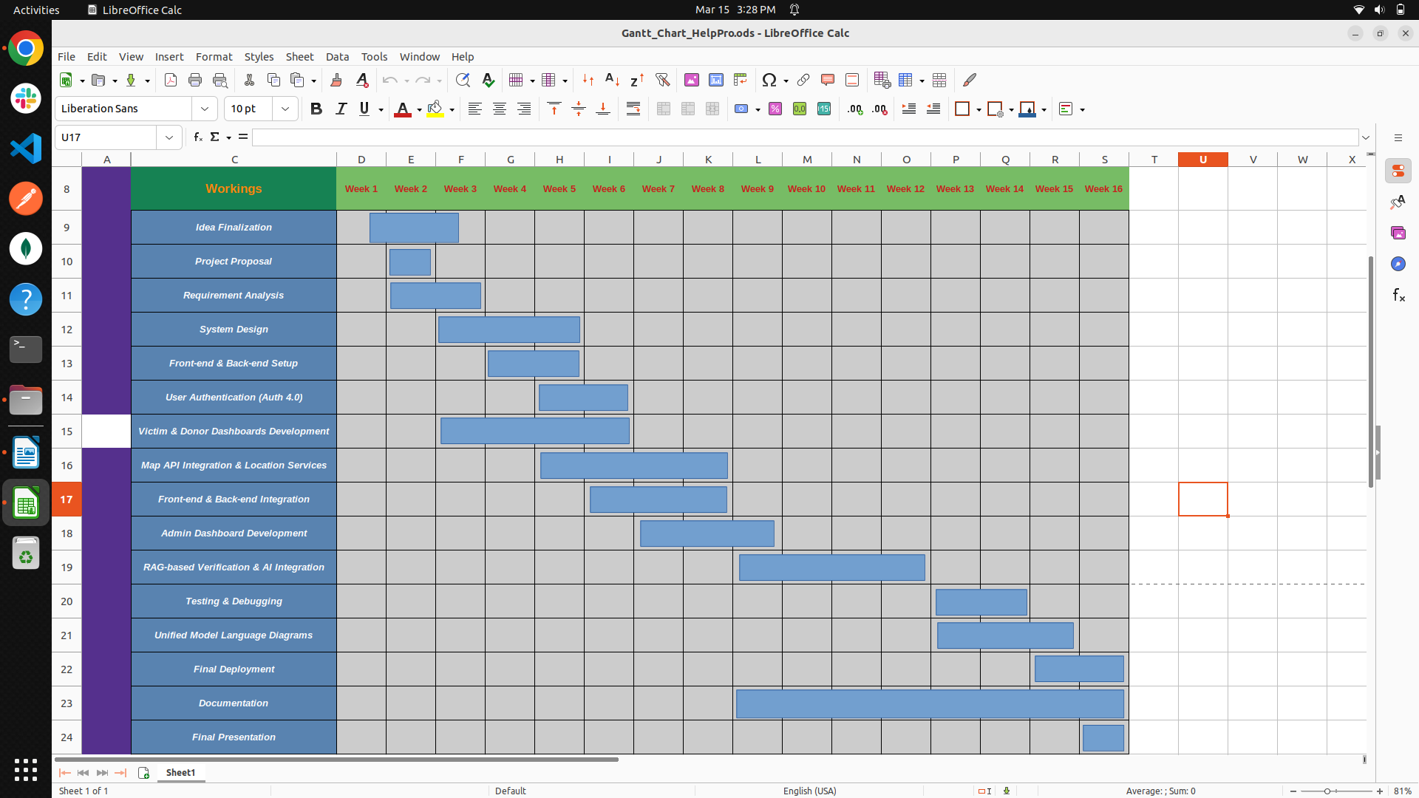
1.3 Report Organization

This report is structured into eight chapters, each covering a specific aspect pf the project development process:
Chapter 1: Introduction provides an overview of the project, the problem it addresses, and a summary of what the report contains.
Chapter 2: Problem description provides the problem description
Chapter 3: Provides the details about the functional and non-functions requirements, use cases, and system constraints.
Chapter 4: Feasibility Study evaluates the technical, operational, and economic feasibility of the proposed solution.
Chapter 5: System Design describes the application architecture, tools, technologies, and design methodologies.
Chapter 6: System Modeling illustrates system behavior and structure using UML diagrams such as use case, sequence, and class diagrams.
Chapter 7: Implementation and Testing provides insights to development process, testing strategies, performance evaluations, and results.
Chapter 8: Last but not the least chapter 8 provides details about the results and discussions about this project.

Chapter 2

PROBLEM DEFINITION
Our own lives can at times feel like we are racing at all times, and adding on exact nutrition and exercise tracking to all of this frantic running around can truly become a huge headache. Hitting the keyboard and typing out every individual ingredient and serving size by hand is not only a waste of precious time, but also leaves the door open to all types of mistakes did I forget to track that added tablespoon of peanut butter? To add insult to injury, many of the programs available today have you toggling your attention between stand-alone food and exercise tracking systems, so you are constantly jumping back and forth between a bunch of screens just to get a good and accurate picture of your overall health.
Pic2Calorie accomplishes this by combining exercise tracking and meal logging into one effortless process. Take a quick photo of what you're eating and let the artificial intelligence carry the load it identifies the food, estimates the calories, and calculates the nutrients for you automatically. And then once you're finished with that exercise session, your calories burned nicely roll into your intake history, providing you one, real-time dashboard for your daily health metrics.
By eliminating tedious manual labor and consolidating all the functionality into one place, we enable our users to be consistent and curious without the maddening frustration of fighting with spreadsheets or toggling back and forth between a half-dozen applications. So what does that lead to, you ask? It leads to the development of good habits that fit nicely into even the most hectic of lives, all because of having solid data on which you can safely depend.

Chapter 3

SOFTWARE REQUIREMENT SPECIFICATION

Introduction

Purpose
This SRS document provides an overview of requirements, features, and design constraints of the Pic2Calorie application. It is a holistic fitness and nutrition management tool, with the functionality of utilizing the most advanced artificial intelligence to perform automatic calorie tracking, while at the same time offering complete workout management. It will simplify health tracking by using image recognition technology to analyze food items and calculate their caloric content. It also offers personalized progress tracking, goal setting, and motivational features that encourage healthy lifestyle habits. The document is a foundational reference for developers, project managers, team members, and supervisors involved in the development lifecycle to ensure clarity of system functionality, user interactions, and non-functional requirements. By following this requirement, the project team will produce a trustworthy, secure, and user-friendly application that would answer the requirements of fitness enthusiasts, health-conscious users, and new wellness starters by maintaining data privacy, performance efficiency, and user engagement.

Document Conventions
The SRS font style is Times New Roman, in accordance with the document norms. For the headings, the main heading uses the heading 1 style with a font size of 16, the subheadings use the heading 2 style with a font size of 14, and the heading 3 style with a font size of 13. The font size used in the paragraph is 12 with line spacing 1.5.

Intended Audience and Reading Suggestions
The different types of reader that the document is intended for:
      - Developers: The document will serve as a technical reference for implementing and maintaining the application.
      - Project manager: Utilize the document to track project progress and ensure alignment with project objectives.
      - Team Members: Refer to the document for understanding roles, tasks, and project requirements.
      - The Project Supervisor: Review the document for over-the-top project deliverables and ensure that standards are up to code.

Product Scope
Pic2Calorie should be a helpful, AI-powered buddy on your phone that makes healthy living convenient with a snap of your food in a flash, you'll see not just the calories but the entire breakdown of nutrients, without needing to enter a single ingredient. For fitness, tracking workouts is just as convenient log sets, reps, or time in a few taps, and Pic2Calorie will calculate calories burned automatically and update your progress in a flash. In the background, the app securely syncs your data across Android 8+ and iOS 12+ devices, so you can pick up where you left off whether at home, the gym, or on the go. While we target about ±10% accuracy for calorie estimates and quick UI response times, we deliberately stay away from supplement tracking, advanced health integrations (like continuous heart-rate monitoring), and any features that appear to be medical advice users always need to talk to a pro for those. Pic2Calorie's strength is in integrating meal recognition, nutrient tracking, workout logging, and goal management into one seamless, hassle-free experience that works well in even the busiest lifestyles.

Overall Description

Product Perspective
Pic2Calorie brings together clever image analysis with simple fitness tracking. It employs the top AI services such as Google Vision or Clarifai to identify foods in the image and then retrieve up- to-date nutrition information from Nutritionix or Ninja Calorie. All this happens over secure Firebase APIs, which handle logins, storage, and live updates on your devices. Since each component beginning from the image model, through the backend database is an independent
building block, we are able to modify or update individual pieces without changing how it looks and feels to you. In short, Pic2Calorie gives you an easy and integrated experience on your screen while working tirelessly behind the scenes with multiple best-in-class services.

Product Functions
Key functionalities of proposed app include:
      - Food Identification: Snap, identify, and track calories in one click.
      - Manual Entry: Scan Nutritionix database for what you eat.
      - Step Tracking: Current step count and estimated automatic calorie burn.
      - Workout Module: Rep/timer preset workouts and burn calculations.
      - Authentication & Profile: Email/password, Google Sign In, profile management.
      - Graphs & History: Charts of daily intake vs. burn.

User Classes and Attributes
Pic2Calorie is offered to a wide range of users with a variety of experience a regular use and System Interaction. The following user classes are identified:

General Users (Fitness Enthusiasts)
Description: People who want to track their diet and exercise with the help of technology.

Traits
    - Frequency of Use: once a day or several times a day.
    - Functions Used: Progress Viewing, workout logging and image based calorie tacking.
    - Technical Expertise: Users of smartphones who are acquainted with health and fitness applications.
    - Security: Basic user privileges, personal data privacy concerns.
    - Educational Level: No particular technical knowledge is required.

Exercise and Diet Professionals
  - Description: The application is used by nutrition coaches, dietitians, and personal trainers to monitor their clients' health.

Traits
    - Frequency of Use: several times a day for multiple clients.
    - Functions Used: Reviewing progress reports, suggesting calorie intake are some of the functions used.
    - Technical Expertise: Moderate to high especially knowledge of health- based app.
    - Security: Restricted to viewing and providing advice, cannot edit users personal information.

Administrator
  - Description: Managers or Developers responsible for managing backend operations and API’s.

Traits
    - Frequency of Use: Regularly for maintenance and observation.
    - Functions Used: Data backup, API’s key management and server monitoring.
    - Technical Expertise: Advanced technical skills with a strong understanding of databases and APIs.
    - Security: Full Access to logs and administrative tools

Operating Environment
This mobile application will be created exclusively for Android due to compatibility issues with devices with minimum specifications given below. However, in order to operate at optimal conditions, the mobile device should contain a quad-core processor, at least 4GB RAM, and at least 3000 mAh battery life so that it lasts for longer periods of usage. Bluetooth and GPS are compulsory because of the integration of wearable devices and location-based features. The smartphone needs to have both front and rear cameras due to location sharing and emergency alerts. The resolution of the screen has to be a minimum of 720 x 1280 pixels in order to support a clear interface.

Design and Implementation Constraints
Mobile devices' limited processing power and battery capacity could impact the app's location tracking and real-time features, particularly during prolonged use. The app's reliance on consistent internet access for real-time location sharing and emergency alerts may pose challenges in areas with poor connectivity. Additionally, the emergency alert system depends on user participation, which may limit its effectiveness in providing rapid assistance without reliable network access. The first version of the application will include a basic set of features, with more to be added in subsequent releases depending on user feedback. There may be some delay in real-time location tracking and emergency messaging due to processing times and network latency. Users may also need some time to get familiar with the app interface and features, hence affecting the adoption rate in the short term.

User Documentation
      - User Manual

With the detailed user manual in Pic2Calorie, the users should never feel stuck at any point using the application, hence all the features should be easily accessible. It would cover the full application from installing to creating the account and even further on how to log calories by means of image recognition and also on logging workouts. There will be a section on troubleshooting common problems so that users may help themselves without needing to report these problems. The user manual is designed for both beginners and advance users, which makes it the ultimate resource for delivering the maximum potential of the application.

Video Tutorials

Pic2Calorie will also include detailed step by step video tutorials of the key functionalities of the app. These visually take users through tasks such as logging meals, tracking exercises, settings goals, customizing a workout plan, and different Workouts and how to do them. These are going to be short visually engaging and easy to follow videos that will make sure users of all technical skill levels have a seamless onboarding experience.

Assumptions and Dependencies
The Application assumes that the user’s smartphone has a working camera or image sensor. Additionally, two crucial needs for the program are an active internet Connection and access to location services. It is presumed that the app’s necessary features and functionalities are supported by the mobile operating system in use. Finally, in order to guarantee optimal performance, the application expects that users run it on devices that either meet or above the minimal hardware requirements.

External Interface Requirements

User Interfaces (UI)

The Home/Dashboard screen gives users a quick and holistic overview of their daily activity, such as total calories eaten and steps walked. The Meal Capture Screen offers a live preview of the camera with a one-tap capture feature that uses an internal machine learning model to recognize food items in real-time. For cases where detection is not practical or for logging past meals, the Manual Log Screen enables users to search for food items with a responsive search bar that uses the Nutritionix API, with autocomplete suggestions to smooth out the experience. The Workout Screen gives users a curated list of exercises, each with customizable controls such as repetition counters or workout timers, followed by calculations of calories burned upon exercise completion. All input data is made available through the History Screen, with a date picker and interactive visual charts to enable users to compare their calorie consumption and burn over time. Lastly, the Profile Screen enables users to set their account settings, view synchronization status with Firebase, and change various app preferences to customize their experience.

Hardware Interfaces

      - Rear Camera: Minimum 8 MP with autofocus for clear meal images used by the on device TFLite model.
      - Processor & Memory: Quad core ARM CPU (≥ 1.8 GHz) with ≥ 4 GB RAM to ensure smooth UI and sub 100ms ML inference.
      - Motion Sensors: Built in accelerometer/pedometer for real time step counting and calorie burn estimation.
      - Connectivity: Wi Fi or 4G LTE for Nutritionix API requests, Firebase Firestore sync, and FCM notifications; offline queueing supports intermittent networks.
      - Storage: At least 500 MB of free flash storage for the Hive local cache TFLite model assets, and temporary images cloud persistence via Firebase Firestore.

Software Interfaces

      - Mobile OS Compatibility: Android 8.0+ and iOS 12.0+
      - Machine Learning Framework: tflite_flutter plugin loads the ResNet50 model for on device inference.
      - Nutrition API: HTTP GET calls via the http package to Nutritionix endpoints for manual food lookups.
      - Backend & Cloud: Firebase SDKs firebase_core, firebase_auth, cloud_firestore, firebase_storage authentication, data sync, image storage, and push notifications.
      - Local Persistence: Hive and hive_flutter for offline caching of meals, steps, and workout logs.
      - State Management: provider package to manage app wide state (auth status, sync state, UI updates).
      - Image Capture: Image_picker for selecting or capturing meal photos from camera/gallery.

System Features
The main functional features of Pic2Calorie are described below, prioritized by their impact on core workflows.

Food Recognition

Description and Priority
This feature performs ondevice image classification of food items using a ResNet50 model converted to TensorFlow Lite. It is the highestpriority feature, as it delivers the core capability of automatically identifying foods and estimating calorie content.

Stimulus/Response Sequences
Stimulus: User captures or selects a photo of their meal.

Response
        - The TFLite plugin runs inference and returns one or more food labels.
        - The app queries the Nutritionix API for each label.
        - Calorie and macronutrient data are displayed for the user to log.

Functional Requirements
- REQ1: Support both single and multiitem recognition within one image.
- REQ2: Complete ondevice inference within 2–3 seconds.
- REQ3: Integrate with Nutritionix (or equivalent) to fetch accurate nutritional data.
- REQ4: Allow users to review, edit, or reject automatically recognized items.

Manual Food Entry

Description and Priority
This mid-priority feature enables the users to look up and record foods manually where automatic identification is not supported, and thorough meal tracking is guaranteed.

Stimulus/Response Patterns
Stimulus: User clicks on "Add manually" and enters a food name.
Response: The app queries the Nutritionix API, locates matching entries with Calorie information, and enables the user to select and record the appropriate entry.

Functional Requirements:
- REQ 1: Allow keyword search through the Nutritionix API.
- REQ 2: Provide auto suggest while the user is typing.
- REQ 3: Verify entries with API responses

Step Tracking

Description and Priority
A medium-priority feature that counts steps via device sensors and calculates calories burned, helpful for users who monitor daily activity.
      - Stimulus/Response Sequences Stimulus: User initiates the step counter.
Response: The program continuously reads sensor readings, counts steps, calculates calories burned, and saves the result.

Functional Requirements
- REQ-1: Pedometer data reading in real-time.
- REQ-2: Utilize standard step calorie burn equations.
- REQ-3: Synchronize step logs into local (Hive) and cloud (Firestore) storage.

Workout Module

Description and Significance
This is a medium-priority feature with pre-defined workouts (by timers or reps) with real-time calculation of calories burned to help users plan their exercise routines.

Stimulus/Response Sequences
Stimulus: User chooses an exercise and specifies reps or time.
Response: Progress is monitored, calories burnt are calculated, and a recap is provided at end.

Functional Requirements
- REQ-1: Incorporate a thorough archive of cardiovascular, strength-building, and flexibility exercising maneuvers.
- REQ-2: Provide individualized rep/timer settings.
- REQ-3: Dynamically compute and log calories burned

Authentication & Profile Management

Description and Priority
Top-priority feature for safe user authentication and customized profiles with customized calorie and exercise suggestions.

Stimulus/Response Sequences
Stimulus: User logs in, registers, or resets password.
Response: Firebase Authentication verifies credentials (email/password or OAuth), then walks the user through profile creation or recovery flows.

Functional Requirements
- REQ-1: Email/password and Google Sign In support.
- REQ-2: Initiate a "forgot password" e-mail process.
- REQ-3: Update user information (age, height, weight, activity level).

Data Persistence

Description and Priority
Top priority feature for secure local and cloud storage of all user data, with continuity between sessions and devices.

Stimulus/Response Sequences
Stimulus: Any create, update, or delete action on food logs, workouts, or profile details. Response: Data is stored in Hive for offline use and synchronized to Firestore when online.

Functional Requirements
- REQ-1: Utilize Hive for low latency, offline access.
- REQ-2: Perform cross device synchronization using Firestore.
- REQ-3: Support offline mode and resolve merge conflicts elegantly

Other Nonfunctional Requirements

Performance Requirements
The Pic2Calorie application aims at delivering high performance while being fast and reliable across supported devices. The image recognition for calorie estimation should handle the processing and result showing within 2–3 seconds. Workout tracking input and data visualization should show updates either in real-time or within 1 second of a user's action. Besides, it ensures that CPU and memory utilization is kept low for the application to run smoothly on low-end hardware such as quad-core processor 2GB-RAM devices. Further, the app is designed with consideration for efficient battery usage without any lag in data syncing with the cloud and a trade-off between functionality and power to enhance the user experience

Safety Requirements
The app includes various safety requirements to ensure proper usage and the protection of information. It is not a medical guide, and users are referred to seek guidance from health care professionals for personal advice. There are disclaimers displayed at various places within the app settings and at the time of registration. The data regarding exercise and food choices are stored securely to avoid unauthorized access. The app abides by the data privacy rules, including the GDPR, to ensure that the information about the user is not misused. The application also gives warnings to users that the accuracy of image recognition would be lower if the lighting was poor

Security Requirements
The app includes various safety requirements to ensure proper usage and the protection of information. It is not a medical guide, and users are referred to seek guidance from health care
professionals for personal advice. There are disclaimers displayed at various places within the app settings and at the time of registration. The data regarding exercise and food choices are stored securely to avoid unauthorized access. The app abides by the data privacy rules, including the GDPR, to ensure that the information about the user is not misused. The application also gives warnings to users that the accuracy of image recognition would be lower if the lighting was poor.

Software Quality Attributes
The Pc2Calorie app is made in accordance with strict software quality standards to guarantee dependability, usability and maintainability. The application has an intuitive user interface that makes it simple to use for users with varying levels of technical expertise. It has excellent responsiveness and availability, tracks exercises with nearly zero latency, and estimates calories appropriately. Furthermore, there are strong error handling procedures in place to help users navigate through potential mistakes brought on by either faulty inputs or bad connectivity. The program can accommodate an increasing user base and future additions because it was created with scalability in mind. Through adhere to industry best practices for software development, Pic2Calorie offers a smooth, effective and pleasurable user interface

Business Rules
Regular users can easily track their workouts, document their meals and obtain comprehensive progress reports to keep tabs on their fitness health journey. Strong management features are offered administrators, such as managing data backups and to guarantee system integrity, keeping an eye ion usage data and supervising API keys. Manual Calorie changes are limited to avoid inaccurate submissions and reserve accuracy. Users must submit clear, well lit photographs for image based meal logging and they will be notified if image quality is below acceptable levels. Additionally, customers that approach their usage limits receive warning messages. Daily API’s usage is also restricted.

Chapter 4

METHODOLOGY
We used a usercentered agile development cycle to build Pic2Calorie, organizing work into twoweek iterations that traded off fast delivery of important features—such as ondevice meal detection and rolledup activity tracking—against ongoing feedback from actual users. Early and frequent demos helped ensure our technical choices (e.g., employing TensorFlow Lite for sub100 ms inference) were consistent with user expectations, and retrospectives helped our code quality and team collaboration increment over time.

Research and Analysis
We started with a deep analysis of leading nutrition and fitness apps (MyFitnessPal, Lose It!, Cronometer), observing usage patterns, database completeness, and frictions—manual entry in particular. Concurrent with this, we interviewed a variety of 12 target users (busy professionals, gym attendees, and nutritionists) to observe actual pain points: diminished motivation when logging was inconvenient, skepticism toward one-size-fits-all calorie estimates, and annoyance at unconnected data in numerous tools. These led to our design choices: instant photo-based logging, unobtrusive sensor streaming, and combined history view.

Requirements Gathering
Equipped with research results, we articulated user needs as such granular user stories as "As a traveler, I want to log meals by snapping a picture in lowsignal areas" and "As a dietitian, I need to export client data for weekly progress reports." This was followed by collaborative workshops with stakeholders to hone acceptance criteria, wireframed major screens in Figma, and mapped functional (image classification, manual lookup, workout logging) and nonfunctional requirements (±10 % calorie accuracy, ≤ 500 ms UI response). Backlog was the basis of our SRS and sprint planning.

Designing Application Architecture
Pic2Calorie follows a three-layer architecture with responsibilities isolated for readability and maintainability. Presentation Layer utilizes Flutter widgets themed for a coherent UI, and reactive state management is offered by the provider package. Business Logic Layer is comprised of Dart services that perform ML inference with TensorFlow Lite, Nutritionix API requests, and data synchronization logic. Data Layer caches data offline with Hive and real-time cloud storage with Firebase Firestore. For the purposes of documenting interactions between systems, we created UML component and sequence diagrams of processes such as camera-to- ML flow and API-to-database integration. The designs were tested through review with emphasis on performance and security to guarantee a scalable and sound architecture.

Training and Integration of ML Model
We assembled a well-balanced 10,000 food image dataset across 15+ categories, with data augmentation (cropping, brightness) added for increased robustness. Fine-tuned ResNet50 achieved 89 % top1 accuracy on our validation set; we then post-trained with quantization and quantized the model to.tflite, confirming sub100 ms inference on a mid-range Android phone and an iPhone SE. An inference adapter in Dart encapsulates model loading, makes prediction calls, and handles confidence thresholds—falling back to manual entry below 70 %.

Front End Development in Flutter
Pic2Calorie's front-end was built with Flutter, providing users with a seamless and visually consistent experience. Meal logging has a full-screen camera view with real-time suggestions from the ML model, where taking a photo of a meal prompts a classification dialog. Manual logging has a debounced search bar tied to the Nutritionix API with autocomplete suggestions, and a portion-size slider for accurate logging. Workout has a list of over 100 exercises, where users can log reps, sets, or duration, and calories burned calculated using MET-based equations. History employs interactive bar and line charts constructed with charts_flutter, with features such as date filtering and pinch-to-zoom. The design is consistent with consistent design tokens and reusable widgets, with accessibility features such as large tap targets and high-contrast text for improved usability by a wider audience.

Backend & Data Layer Implementation
Firebase is the foundation for user authentication and cloud data sync within the app. Firebase_auth is employed to support authentication flows, both email/password and Google Sign-In. Data is structured in Firestore in user-specific collections (users/{uid}) and contains meal logs, workout logs, and step logs. Meal photos are stored and backed up to Firebase Storage. Hive is employed as a local cache layer to preserve app usability offline, with a last- write-wins approach to resolve the data sync conflicts upon reconnection.

Testing and Refinement
To attain robustness, there was a thorough quality assurance plan. Unit tests were written to verify ML model adapter output and process different API client responses. Widget tests were run to verify UI rendering and behavior across different states. Integration tests simulated real use by executing whole workflows against Firebase emulators for authentication and Firestore interactions. Performance was monitored actively by benchmarking inference speed, memory consumption, and battery life, a goal to keep battery usage below 2% per hour. Beta testing was completed with 25 early adopters through TestFlight and Play Store internal tracks, giving valuable feedback to guide UI redesign and model threshold tuning.

Deployment
CI/CD pipelines were automated using GitHub Actions. Each pull request triggers linting by flutter analyze, auto-testing, and APK/IPA builds on Ubuntu and macOS runners. Main branch merges trigger deployment to beta testers via TestFlight and Play Store internal test tracks. App stability and feature usage in production are tracked using tools like Crashlytics and Firebase Analytics and feed back into future development cycles. Version control and rollback scripts ensure releases are traceable and reversible if needed.

Documentation and Reporting
supported the construction and ongoing upkeep of the project. A comprehensive Developer Guide, in README.md, covers setup, architecture diagrams, and coding standards. A User Manual in PDF includes screenshots with annotations and troubleshooting procedures for end
users. Video tutorials, on YouTube, demonstrate prominent features like meal logging, workout input, and monitoring progress. Inline code comments were also maintained within the codebase to support new contributors and facilitate long-term scalability and maintainability of the project.

Tools and Technologies

Flutter & Dart

Flutter is an open source UI Software Development toolkit created by Google, and Dart is the Programming language used with Flutter. Flutter allows for building natively compiled applications for web, IOS, mobile and desktop from a single codebase. IT offers a rich set of pre- designed widgets and tools, enabling rapid UI development with expressive and flexible Components. Dart with its ahead of time (AOT) and just-in-time (JIT) compilation, contributes to both fast development cycles and optimized app performance in the production.

TensorFlow Lite (tflite_flutter)

TensorFlow Lite is a lightweight version of TensorFlow designed for mobile and embedded devices. The tflite_flutter plugin enables seamless integration of TFLite models in Flutter applications. In this project, it is used to perform on device interference for food detection, utilizing a custom trained ResNet50 model. This ensures low-latency predictions without relying on internet Connectivity making the app faster and more reliable.

Hive & hive_flutter

Hive is a lightweight and faster key database written in pure Dart. It is idea for Flutter applications due to its low overhead and high performance. The hive_flutter plugin provides a convenient integration with Flutter widgets. Hive is used in the application to store local data such as user profiles, meal logs, step counts, and workout history, enabling offline access and fast data retrieval.

Firebase (Authentication, Firestore, Storage, Cloud Messaging)

Firebase is comprehensive backend as a service (BaaS) platform. The application utilizes several Firebase components.
      - Firebase Authentication is used for secure user login, signup, and password reset functionalities, supporting both email/password and Google Sign-in methods.
      - Firestore is used as a real time No SQL cloud database to store user data, step counts, calories, workout logs in a structure Format per user-ID.
      - Firebase Storage is utilized for uploading and retrieving images taken during food logging.
      - Firebase Cloud Messaging (FCM) is used to send notifications and alert the users enhancing engagement and communication.

Nutritionix API via http

The application integrates the Nutritionix Api to Provide nutritional Information for food items entered manually by the user. This is Implemented using Flutter http package that enables seamless communication with external web services. The API return data such as calories, macronutrients, and helping user’s track their meals.

State Management with provider

Provider is a widely recommended state management solution in the Flutter ecosystem. It helps manage and propagate state changes across the widget tree efficiently. This project, provider is used to handle user sessions, profile data, calorie information, steps tracking, and workout information ensuring a reactive and organized architecture throughout the app.

Data Visualization with charts_flutter

The Charts_flutter package is used to present calories consumed and workout calories burned in engaging manner. It supports Interactive charts and graphs, which are used in the application to display calorie intake vs calorie burned, daily steps taken etc. This enhances user comprehension of their health metrics.

CI/CD with GitHub Actions

For the sake of development effectiveness and code integrity, GitHub Actions is used for Continuous Integration and Continuous Deployment (CI/CD). It is used to automate tasks such
as running tests, compiling the application, and deploying it into test environments each time code is pushed onto the repository. This keeps the codebase stable at all times and production- ready.

Hardware and Software Requirements

Hardware Requirements
The app requires a device with Android 8.0 (Oreo) or iOS 12.0 or higher to maintain compatibility with Flutter and support libraries. The device should have a minimum 8-megapixel rear autofocus camera to capture clear, well-defined food images, which are then processed using the on-device TensorFlow Lite model to identify food. The device should also support a quad- core 1.8 GHz or higher CPU and at least 4 GB of RAM to support easy user interaction and to enable efficient machine learning inference under 100 milliseconds. For enabling local caching of data, model files, and temporary image storage, the device should offer at least 500 MB of available storage.

Software Requirements
The app development and deployment are facilitated by several software elements. Flutter SDK (at least version 3.0) and Dart (at least version 2.18) are required to deploy and develop the app. Firebase setup is done using Firebase CLI to integrate the app with Firebase services such as Authentication, Firestore, and Storage. An active Nutritionix API key is also needed to fetch nutrition information about food items while manually entering them. Git is also utilized for version control and GitHub for collaborative development and CI/CD automation through GitHub Actions.

Chapter 5

DETAILED DESIGN AND ARCHITECTURE

System Architecture
Pic2Calorie, in our senior project, followed the system architecture to make our application user friendly and intelligent in situations users want to guesstimate calories through food images. The architecture includes multiple sub-projects that all work together toward this goal, and relies heavily on computer vision, machine learning, and mobile. In the core of the proposed workflow is the TensorFlow Lite model used to classify food and estimate calories from input images. This model was trained using deep learning model such as ResNet-50 and converted to a mobile version. tflite format for maximum efficiency and compatibility with Flutter. The front-end design using Flutter is the user interface of the application and provides an input for the images via camera/gallery, to display real-time results and calorie related information. It manages user interaction, entering/storing data, and transitioning between views. The UI is light and responsive, creating a user-friendly style. The image processing pipeline is a crucial “middleman” between user input and model inference. The images are resized, normalized and then fed through the TensorFlow Lite interpreter in the app, following the model’s input constraints. There are two layers, data layer which is static food datasets for the training, and provides real-time predictions during the use of the app. Food category labels, level estimates of calories, and other food information are combined to deliver informative feedback. It's also only the model implementation (preprocessing, training, evaluation and conversion) that's written in Python, depending on PyTorch and TensorFlow. The trained models are validated and tested before exporting to the mobile format using the TensorFlow Lite converter code using python. Asset management There will be storage of the model files, dataset images, label maps and related documentation in the project structure in backend for training and in mobile application for inference. The app also uses local storage to store user sessions. The architecture supports
potential future extensions like nutrition tracking, meal logging, or even cloud integration for dynamic model updates and leaderboard-style health tracking among users. The modular design makes it scalable and adaptable for future enhancements.

Architecture Design Approach
The modularity and layered architecture approach is the design methodology that has been used in the Pic2Calorie application, which is in line with methodologies used in well-structured interactive systems. This approach centers on the logical division of the application components into individual layers with detailed, well-described functionalities. Effectiveness, scalability, and maintainability are the key design aims—primarily the main design objectives—central to the overall system architecture. The architecture is separated logically into layers like the presentation layer (user interface), application logic layer (image processing, preprocessing, and model inference), machine learning layer (trained TensorFlow Lite model), and data management layer (food category metadata and calorie mappings). Each stratum performs separate tasks, making debugging, development, and future development easier. This modular architecture also promotes clarity of responsibility, with distinct demarcation between UI rendering, image processing, model execution, and user feedback delivery. The user input and presentation of output are handled by the front-end of Flutter-built apps, with the background executing TensorFlow Lite model for real-time prediction. The module for data management supplies model labels and estimated nutritional values to support the predictions. Apart from that, this tiered structure encourages tiered development, where the machine learning model, Flutter interface, and logic components can grow independently. Through this method, changes in one layer (e.g., model update or UI improvement) do not impede the functioning of other layers. Such abstraction and collaboration between layers offer a well-integrated and optimized user experience. Finally, this architecture offers a good foundation for future expansion, enabling the system to evolve over time to accommodate sophisticated features such as cloud inference, personalized recommendation, or user history.

1. 2 Architecture Design
Pic2Calorie is designed with a layered architecture to promote simplicity, modularity, and scalability. There is a particular function of each layer to provide an effective calorie estimation
experience through food image analysis. The User Interaction Layer manages the interaction of the user with the application, including image capture or selection and result display. The Presentation Layer manages the user interface, with a responsive and minimal design using Flutter. The Application Control Layer serves as a middleman between the front end and machine learning logic. It handles images, initiates predictions, and controls calorie estimation workflows. Essentially, the Machine Learning Inference Layer runs the TensorFlow Lite model that recognizes images of food and offers real-time estimates of calories. The Data Management Layer retains label mappings and nutritional information so that model outputs can be properly interpreted. Auxiliary materials like images and models are stored in the Assets and Resources Layer. There is also an External Services Layer in the plans for adding future features like cloud model revisions or web-based databases. The architecture future-proofs the app, optimizes it, and simplifies maintenance.

3 Subsystem Architecture
In Pic2Calorie, every layer of the system consists of expert subsystems that cooperate to provide fundamental functionality. In the Presentation Layer, Flutter UI components are responsible for the display of screens, user input, buttons, image previews, and prediction results. The Application Control Layer comprises modules for managing image preprocessing, TensorFlow Lite model loading, and execution of the prediction logic. The modules manage the primary control flow from the interface to the AI engine. Within the Machine Learning Inference Layer, the combined .tflite model is the core prediction engine, annotating input images and providing estimated calorie outputs. Optimized for mobile accuracy and performance, it is. Data Management Layer consists of label files, calorie mappings, and configuration data to convert the model predictions into consumable nutritional feedback for the user. It also provides future potential storage for storing user history or logs. Assets and Resources Layer is in charge of the handling of static assets such as the TensorFlow Lite model file, app icons, food category images, and other UI assets for a visually consistent experience. Some of the reference modules in the Optional External Services Layer are meant to facilitate future integration with cloud services for model updates or remote-calorie databases. All of these subsystems are tightly coupled together to facilitate smooth user interaction, efficient processing, and
extensibility—enabling Pic2Calorie to behave as an intelligent and intuitive mobile calorie estimation software.

Detailed System Design
The Pic2Calorie Detailed System Design explains how all the subsystems work and interact in order to present proper food classification and calorie calculation. The document is a development technical guide and future improvement manual. The Presentation Layer, which is implemented with Flutter, handles user interaction like image selection and result display. It provides a responsive and fluid interface on devices. The Application Control Layer carries out image preprocessing, model calling, and result formatting. It offers a bridge between the UI and the internal AI logic with optimal control flow. Essentially, the Machine Learning Inference Layer executes a TensorFlow Lite model of ResNet-50 that operates on food images and optimizes predictions on the mobile end. The Data Management Layer handles label mappings and calorie data utilized to translate model outputs. It also offers scalability for storing user history or future data logging. Static data like the trained model and media are kept in the Assets and Resources Layer to ease integration into the app's UI and logic. A Future Optional External Services Layer is reserved for future cloud-based functionality, such as model updates or synchronization of user data.

Classification
Component: Detailed System Design of "Pic2Calorie".

Definition
This section provides a system level overview of the Pic2Calorie project, Outlining the main components and how they work together. It explains the purpose of each subsystem and how their interactions help achieve the overall goal to the app image-based recognition, and calorie estimation on mobile devices.

5. 2. 3 Responsibilities
The TensorFlow Lite-driven machine learning sub-system identifies foods from images presented by users. The sub-system accepts visual inputs and generates a category label. The control layer transforms the label into consumable calorie information. UI handles input/output
processing and data modules provide reliable label-calorie mapping. All these components are integrated to generate quick, precise, and user-friendly predictions.

Constraints
Mobile hardware limitations affect model performance and UI responsiveness. The TensorFlow Lite model must be kept light to enable real-time inference without taxing device resources. Additionally, memory as well as storage limitations limit the size of the embedded assets and model complexity employed in the app.

Composition
The Machine learning subsystem in Pic2Calorie consists of several key components.

      - Preprocessing Module: Prepares images for model input by resizing and normalizing.
      - TensorFlow Lite Model: Classifies Food items using a lightweight deep learning model.
      - Prediction Mapper: Maps model output to food labels and corresponding calorie values.

Uses/Interactions
The Machine Learning subsystem receives image data from the Presentation layer and processes it through the model. Prediction Results are passed back to the Application Control Later, which then updates the UI with classification and calorie estimation for the user.

5. 2. 7 Resources
This Subsystem requires computation power to run the model on device using TensorFlow Lite. It uses memory to store the model, label map, and related configurations files for food categories and calorie values.

5. 2. 8 Processing
The Image is passed through a preprocessing pipeline and the fed into the Tflite model. The model performs classification and outputs a label index, which is then mapped to a food item and estimated calorie value.

5. 2. 9 Interface/Exports
This subsystem exposes functions to load the model, preprocess input, run interface, and return results. These Interfaces are used by the Application Control Layer to trigger predictions and fetch outputs for user display.

5. 2. 10 Detailed Subsystem Design
The Pic2Calorie Detailed Subsystem Design provides a detailed overview of every key component of the application and how all the components communicate with each other to deliver the required functionality. This phase is focused on specifying the role, behavior, and interaction of every subsystem in such a way that it is scalable, performance-efficient, and maintainable. Each subsystem is considered in detail, offering information about its working logic, internal processes, and interaction with other application layers. At the heart of the system lies the Machine Learning Inference Subsystem, which accomplishes the classification of the food images entered by users. On a user selecting or taking a picture, this subsystem first processes the input through an image preprocessing pipeline. This involves resizing the picture to adhere to the model's input size, normalizing pixel values, and arranging the image data to adhere to the TensorFlow Lite interpreter. After having prepared the picture, the pre-trained model, which has been optimized for mobile deployment through TensorFlow Lite, is invoked to perform inference. The model returns a classification outcome in the form of an index, which is subsequently translated into a human-understandable food label and its approximated calorie value through an internal mapping system. This subsystem is not an isolated subsystem. It is closely integrated with the Application Control Layer, which manages the data flow between the backend model and the frontend interface. After inference, the outcome is passed to the Presentation Layer, which displays the prediction and calorie estimate to the user in an interactive and understandable format. This smooth flow guarantees a smooth user experience, where inputs and outputs are handled quickly without lag. Behind this basic ability is the Data Management Subsystem. This level holds and manages structured data used across the application, including food category descriptions, calorie data, and configuration files. It ensures consistency and correctness in data retrieval and management, especially in the keeping of user sessions or the facilitation of future features like usage history. The Assets and Resources Layer is equally crucial to the design since it stores all the static assets the application needs to operate. These consist of the TensorFlow Lite model file, sample images, and map configurations. They
are organized and loaded in such a way that performance bottlenecks are avoided, particularly in low-end devices where processing capability and memory are limited. To enable modular development and ease integration, well-documented interfaces are defined by each subsystem. Interfaces offer functions for initialization, image processing, model inference, and retrieving results. Modular architecture posits that the machine learning model or presentation logic may be altered independently, thus maintainability and scalability. Performance constraints are considered meticulously while designing this subsystem. Because Pic2Calorie is designed for mobile platforms, optimizations are made to keep the model slim, memory-conscious, and minimize inference time. Model quantization and optimized image processing are used to make predictions in near-real-time without draining the device. In a deployment at full capacity, this design would be accompanied by flowcharts, pseudocode, or diagrams to illustrate graphically how the system processes input data from when a user posts a photo, through preprocessing, classification, and finally result presentation. The graphics enable developers to understand the internal structure and significance of each of the subsystems and to integrate all the components of the system while developing it.

Use case Diagram
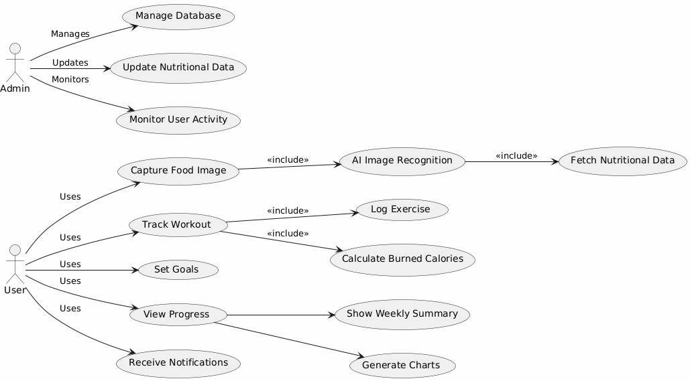

Figure 1: Use Case Diagram
This Pic2Calorie application Use Case Diagram illustrates interactions within a nutrition and exercise tracking system. It illustrates user interactions like photo-based food diary, exercise
logging, goal setting, and progress tracking. AI automatically estimates calories and generates reports, and administrators monitor user activity and database update. Notifications enable user interaction and reminder of goals

Sequence Diagram
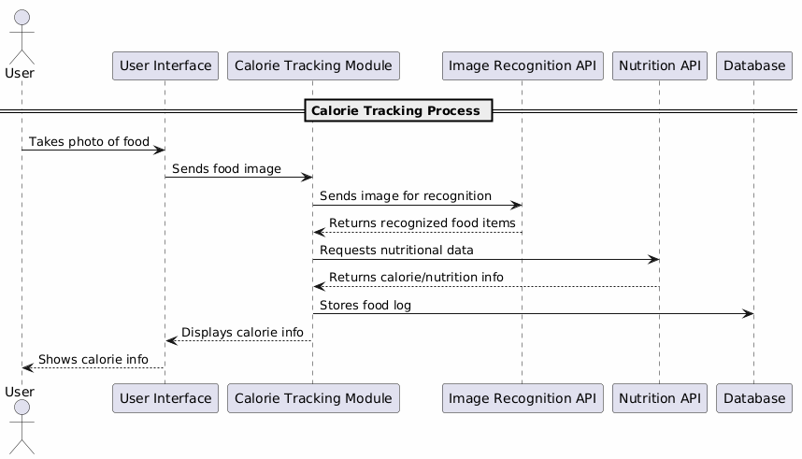
Figure 2: Sequence Diagram
This image illustrates the end-to-end process of real-time calorie counting for food using AI. A user takes a photo of food, which is interpreted by an image recognition model; the system retrieves calorie information via a nutrition API. The most significant components are the user interface, calorie tracking module, APIs, and database. The flow of data is from the user to the system to provide results

Data Flow Diagram
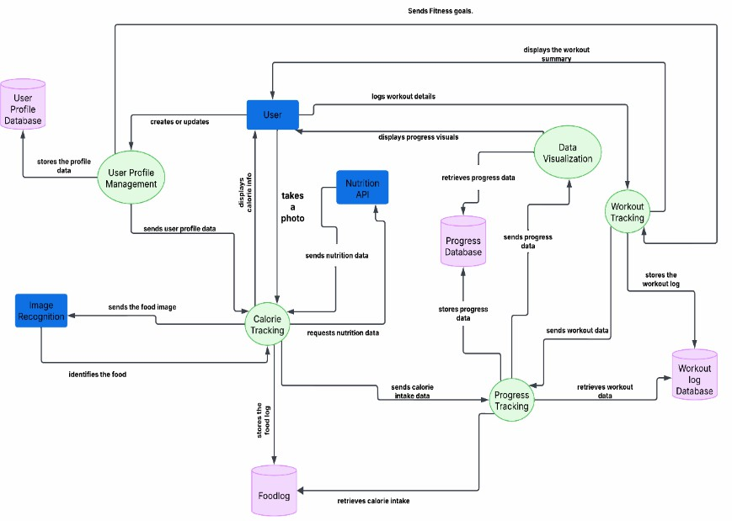

Figure 3: Data Flow Diagram
This picture shows data flow within the Pic2Calorie app, from user profile management to workout and nutrition logging (image-based and manual) and viewing progress. Users input data, which are processed and stored in several databases (profile, workout, food log, progress). AI image recognition and a Nutrition API enable automated calorie logging. Progress data is collected and visualized by the system for user insight

Activity Diagram
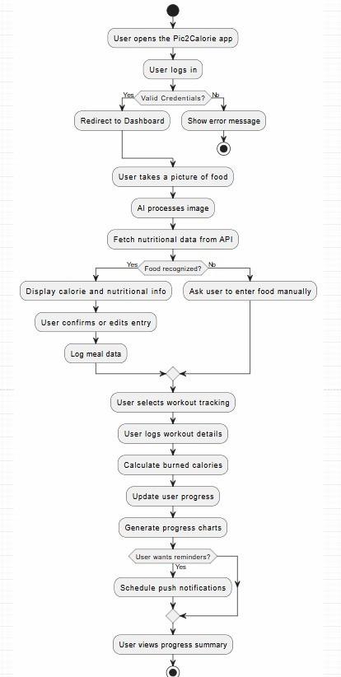

Figure 4: Activity Diagram
This Diagram describes the user interaction process of the Pic2Calorie application from login to seeing a progress overview. Users login and take pictures of food for AI-assisted nutritional analysis or input manually. Workouts are monitored, and calories burned are computed. The
system is updated and displays progress, with push notifications available for reminders. The last step allows users to view an overview of their fitness journey
.

Architecture Diagram
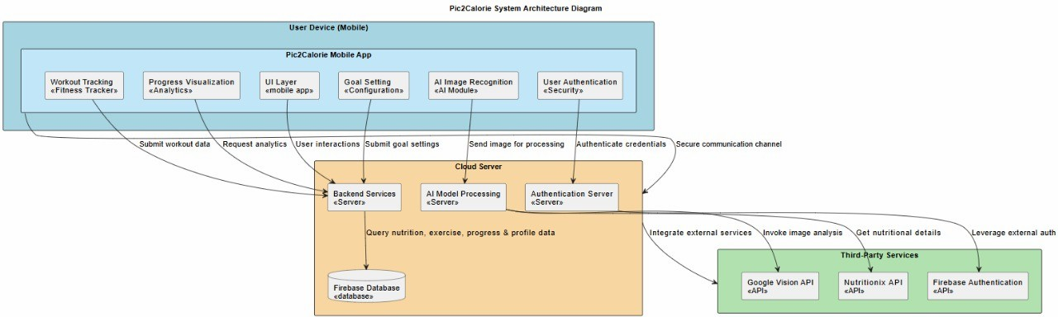

Figure 5: Architecture Diagram
This figure illustrates Pic2Calorie app system architecture, illustrating interaction among the external services, user's mobile phone, and cloud server. Mobile app performs UI, exercise logging, goal setting, and AI-based image capture, which securely sends to the cloud. Cloud server performs backend logic, AI processing, and Firebase storage. External services such as Google Vision, Nutritionix, and Firebase Auth provide photo recognition, nutritional information, and secure authentication.

Database Diagram
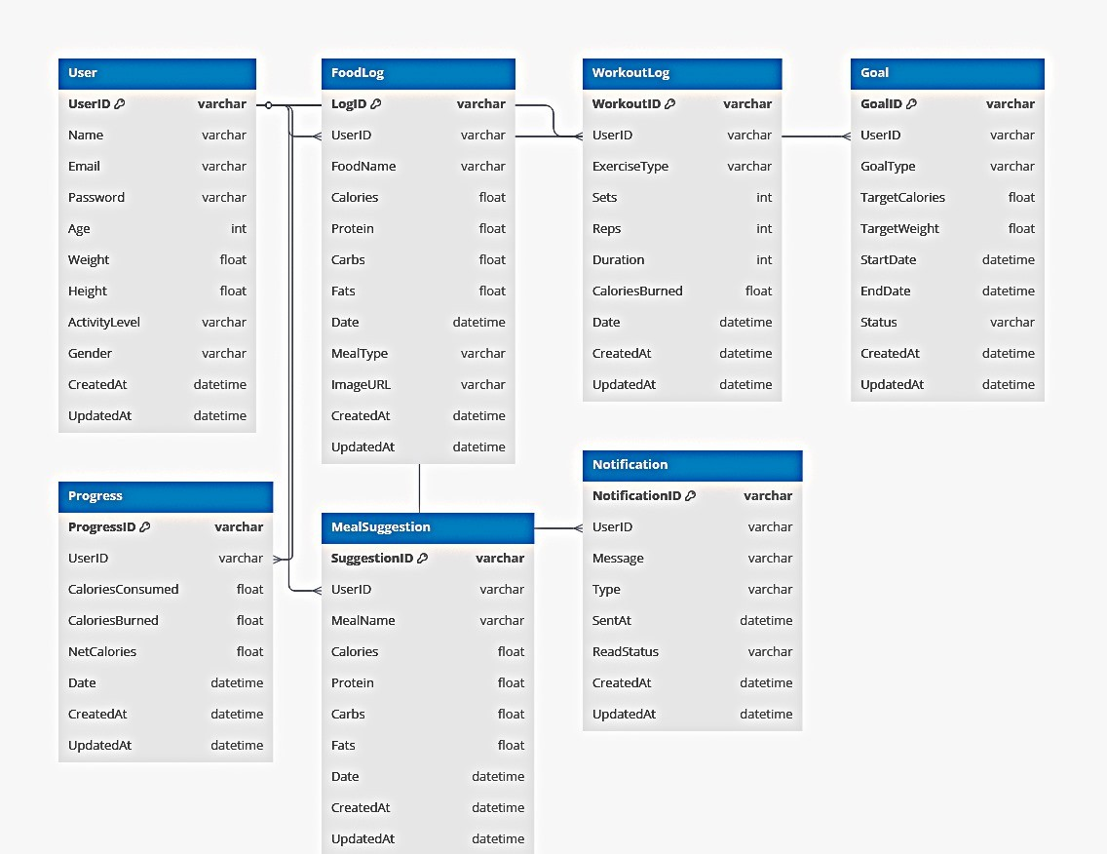
Figure 6: Database Diagram
This is the Pic2Calorie app database schema, including the structure and relationships of main tables. It has User, Food Log, Workout Log, Goal, Progress, Meal Suggestion, and Notification tables. Each record has corresponding user, meal, workout, and goal data, and all tables are referenced by a foreign key to the User table. This schema enables individualized tracking, goal upkeep, and notification in the app.

Component Diagram
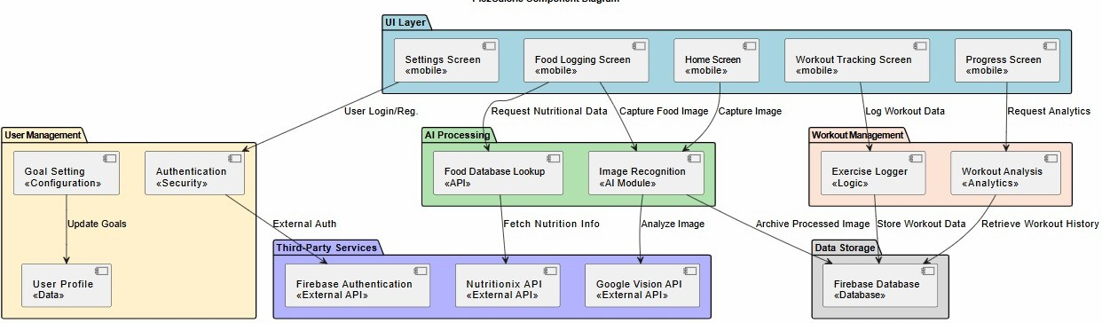

Figure 7: Component Diagram
This component diagram depicts the architecture of the Pic2Calorie app, segmenting it into UI, User Management, AI Processing, Workout Management, and Data Storage. The UI layer manages user interaction and talks to backend modules. User Management manages authentication and profiles, and AI Processing employs Google Vision and Nutritionix APIs for food detection. Workout Management tracks and analyzes exercise data. Firebase hosts all data, with third-party services aiding core features.

Package Diagram
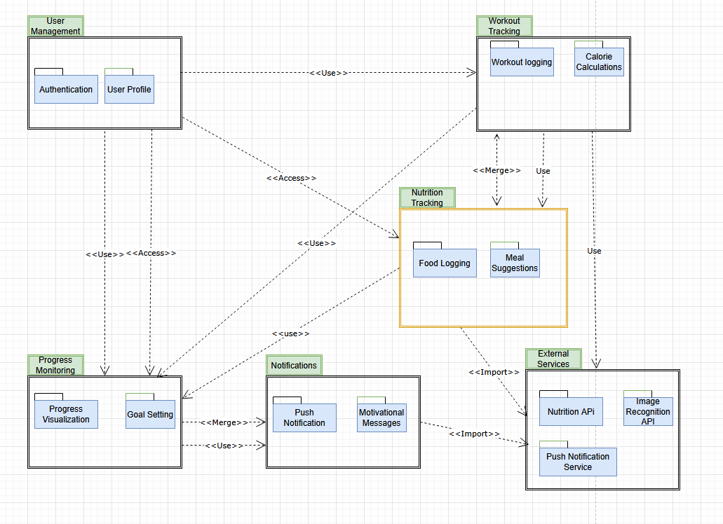
Figure 8: Package Diagram
This diagram illustrates package diagram of Pic2Calorie application. It structures the system into packages such as user management, progress monitoring, workout tracking, and notifications. It This package diagram is showing the overall architecture of the Pic2Calorie app, which is decomposed into major functional components: User Management, Workout Tracking, Nutrition Tracking, Progress Monitoring, and Notifications. Nutrition Tracking and Notifications rely on External Services (e.g., Nutrition API, Image Recognition, Push Notifications). User Management is used by Workout and Nutrition Tracking modules to read user data, and Notifications are coupled with Progress Monitoring to deliver customized messages.

State Diagram
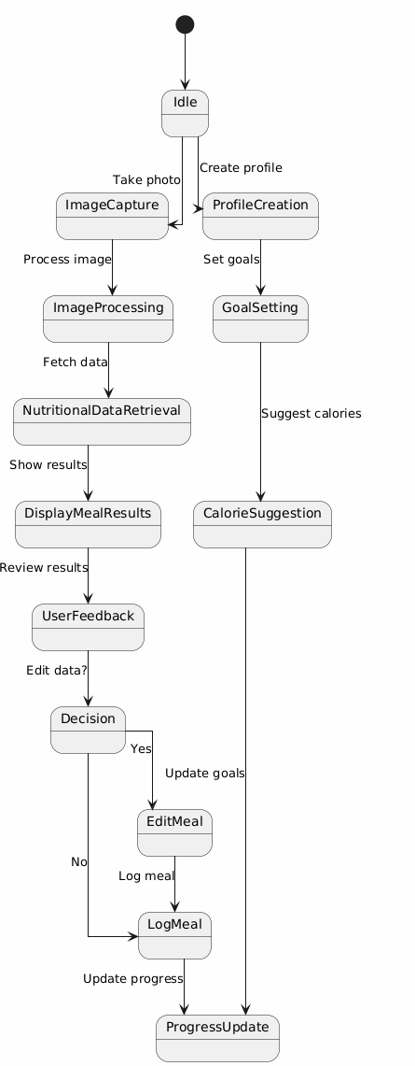
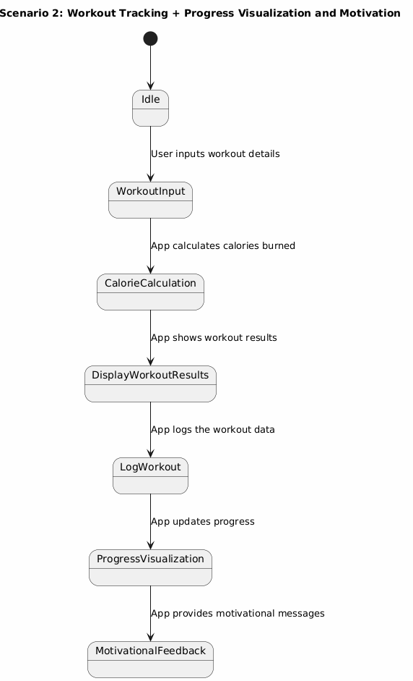
Figure 10: State Diagram
This diagram illustrates the combined process flow of workout tracking and calorie management in the Pic2Calorie app. Food images are used for user meal logging for AI-aided nutrition analysis and workouts are manually logged for a computation of calories burned. Profile creation, goal setting, and provision of customized calorie recommendations and motivational
messages are supported by the system. The tracked data is used in ongoing progress tracking and visualization.

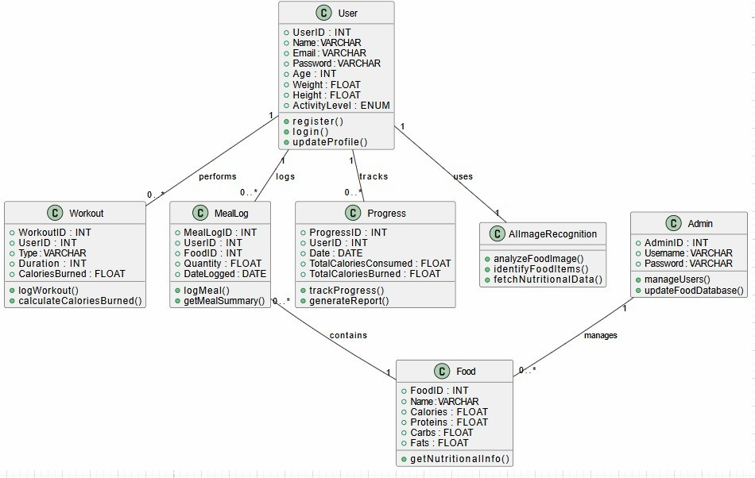
Class Diagram
Figure 11: Class Diagram
The next figure shows the Pic2Calorie Monitoring System, wherein users are assigned profiles, enter workouts and meals, and see daily progress. Workouts involve type, length, and calories burned; meals are associated with food items and nutrition facts. Progress tracks calorie burn and consumption, based on workout and meal information. Admins manage user accounts and the
food item database. Image recognition enables automated logging of meals through identification of food and fetching of nutritional facts.

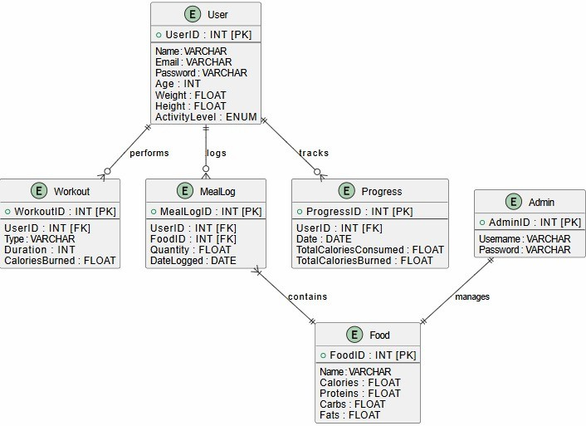
ER Diagram
Figure 12: ER Diagram
This Entity-Relationship Diagram (ERD) is a fitness and diet monitoring system with key entities: User, Workout, Meal Log, Progress, Food, and Admin. Users log workouts and meals, and progress, with meals associated with a particular food item. The system monitors calories burned and calories ingested, with workouts monitoring type and duration. The Food entity holds nutrition information, and Admin handles the food database. The relationships guarantee users have multiple workouts, meal logs, and progress entries, and meal logs refer to both users and food items.

Chapter 6

IMPLEMENTATION AND TESTING
This chapter discusses the implementation and testing of the Pic2Calorie application, which combines cutting-edge machine learning and Flutter to build a health-tracking system. The system is built using Flutter and Dart and Firebase for backend services and Hive for storage. Features of food detection, calorie logging, exercise logging and user profile management have been implemented and tested extensively. The backbone model used for this app is ResNet50, a convolutional neural network, which has been fine-tuned on specific food categories. The model is trained on PyTorch and subsequently transferred to TensorFlow Lite (TF-Lite) for deployment on Flutter. The conversion process is achieved by saving the PyTorch model into the ONNX format, then ONNX is converted into TensorFlow, and then TensorFlow model is converted to TensorFlow Lite by the TensorFlow Lite converter to get a .tflite file. The TFLite model is subsequently used on the Flutter app to perform real-time food identification. Version control was done using Git and GitHub, which gave a clean environment for code management, collaboration, and testing using branches. Feature development was done on separate branches independently and then tested and merged to maintain the main branch intact. This gave clean development streams, simple debugging, and simple tracking of progress.

Core Functionalities in Narrative Format
- Image Selection and Capture: The users can either select a food image from their gallery or take a new one using the camera of the device. The UI, developed in Flutter, makes it possible to do this in a simple way.
- Image Preprocessing: The image is resized and normalized upon selection to adhere to the input specifications of the in-built TensorFlow Lite model. This is achieved to ensure uniformity for correct model inference.
- On-Device Inference: The image is passed to the embedded .tflite model, which performs inference on the device for offline and fast use.
- Prediction Mapping: Raw model output is converted to a readable food label through a mapping defined ahead of time. It is then paired with a known calorie value from storage so result generation is a matter of minutes.
- Result Display: The food item and calorie are calculated and displayed to the user in a responsive interface. The result is displayed in a clean format, both in text as well as in visualizations for a professional user interface.
- Performance Optimization: Every function is optimized for performance. The model runs with no lag, and the app remains lightweight to support lower spec devices.

Development Methodology and Tools
The development of the Pic2Calorie app was carried out through an iterative and incremental development process. This permitted incremental feature growth and frequent checking against functional specifications. The app was developed with Flutter, a cross-platform UI framework powered by the Dart programming language, appropriate in delivering a consistent user experience on Android, iOS, and web platforms.

Development Tools Used
- IDE: Visual Studio Code, Android Studio
- Version Control: GitHub
- Backend: Firebase (Authentication, Firestore)
- Local Storage: Hive Database Storage
- Machine Learning: TFLite (integration), PyTorch (training), TensorFlow (conversion).
- APIs: Nutritionix API, NinjaCalorie API
Packages like firebase_auth, cloud_firestore, hive, tflite_flutter, and http were central to the implementation. Official Flutter documentation was heavily referenced for best practices and templates for keeping the code clean.

Machine Learning Model Integration
Model training was initiated using the pre-trained ResNet50 model found in the PyTorch deep learning environment. The model's final fully connected (FC) layer was adapted to include the particular number of food classes in the application—13, in total. The classes represent typical foodstuffs like apples, bananas, burgers, etc. The training data set was made up of images for every class that were labeled. Transfer learning was used to fine-tune the model, whereby most of the layers of the network are fixed and only the top layers are trained using the new data set. This method speeds up training and enhances accuracy with a relatively small data set.

Conversion from PyTorch to TFLite
Once training was completed, the PyTorch model itself could not be directly implemented in Flutter. Therefore, a step-by-step model conversion process was employed.

Export to ONNX (Open Neural Network Exchange)
The model was exported in ONNX format with torch.onnx.export(). The format is an intermediate representation and can enable interoperability among different machine learning frameworks.

Convert ONNX to TensorFlow
The ONNX model imported with onnx was converted to a TensorFlow model with onnx-tf.

TensorFlow to TensorFlow Lite (Tflite)
TensorFlow SavedModel was converted to a.tflite using tf.lite.TFLiteConverter to be used on
mobile.
Saving Tflite Model
The model was saved as model.tflite after conversion and was bundled in the Flutter assets for deployment.

Functionalities Implemented

Food Detection Using TFLite
The Pic2Calorie application employs a strong on-device machine learning model to identify food items via the device camera. This is achieved by employing a TensorFlow Lite (TFLite) model that has been taken from a pre-trained ResNet50 model. The model was initially fine-tuned in PyTorch to classify 13 in-app food categories particular to the application. It was then exported as an ONNX model, converted into TensorFlow, and finally converted into a .tflite model by employing the TFLiteConverter python code. In the Flutter app, the TFLite model is preloaded with the tflite_flutter plugin. When the user captures or selects an image, the image is preprocessed—resized to 224x224 pixels and normalized—before it is passed to the model to make inference. The model's output is the index of the recognized food class, which is translated to a human-readable food label (e.g., "apple", "banana", etc.). The label, timestamp, and image data are stored locally using Hive and pushed to Firebase Firestore for cloud storage and cross- device syncing.

Manual Food Label Entry with Nutritionix API
Along with the automated food detection, the application also supports manual food entry in order to handle the case where detection is not possible or when direct input is desired by an individual. A user can optionally input a food item into a search box that triggers a REST API call to the Nutritionix API. The API examines the input and gives out extensive nutrition facts like calories, carbs, proteins, and fats. This is achieved by integrating with the http package in Flutter. After receiving a response from Nutritionix, the data is parsed and displayed to the user in a structured manner. The response is locally stored in Hive and remotely in Firebase so that it can be retrieved even after an app restart. This feature bridges the gap between ML-based recognition and user-controlled input, making it more accurate and flexible.

Step Counter Functionality
To track activity on a day-to-day basis, the app uses the device's internal pedometer sensors via the pedometer plugin. The plugin tracks real-time step information via the stepCountStream, which gets refreshed when the user is walking or running. The app subscribes to the stream and refreshes the UI and database in real-time. Every new step count is saved in a local Hive box to retain it in the event of offline use or app restart. The step data is also transmitted to Firebase to
allow device syncing. This two-layered store ensures data resilience and user continuity, and physical activity data is always current.

Workout Logging and Calorie Calculation
Pic2Calorie features an exercise module that is explicitly intended to enable recording exercises either by time or reps. A given exercise category, such as jumping jacks or push-ups, is associated with a set rate of calorie burn based on typical MET values or user-defined functions. Reps can be entered, or a timer is used for exercises done by time. The moment a workout session is completed, the app determines calories burnt from formulas that take into account workout type, user weight, and workout duration. A popup is displayed to inform the user of calories burnt. This is stored in Hive and Firebase for historical purposes. A chart on the home page aggregates this information to display daily, weekly, or monthly trends using charting libraries such as fl_chart.

Firebase Authentication (Email & Google Sign-In)
User authentication is gracefully managed by Firebase Authentication to offer secure login using Email/Password and Google Sign-In. The firebase_auth plugin manages all the authentication operations, while google_sign_in is used for Google integration. Users are able to sign in using their email, log into their account, or reset their password through the "Forgot Password" option. Once the reset is initiated, Firebase guides the user through their email through a password reset link. Authentication tokens are internally and securely managed by Firebase, and data is accessed through the user's UID in Firestore.

Profile Management
Each user is allowed to have a full profile with name, age, weight, and height. These are stored in Firebase Firestore in a document with the UID of the user as the key. Editing these is supported by the app, and updates are synced to Firestore in real time. Profile data is critical in calculations for personalized calorie expenditure during exercise and recommended nutritional intake. By having it stored remotely, it also ensures that users are able to access their data on any device.

Persistent Local Storage with Hive
A major design decision in Pic2Calorie is the use of Hive, a lightweight key-value database, for offline-first support. Hive is used to store:
      - Food items being detected or entered manually.
      - Steps Counted everyday
      - Workout logs that shows how much calories burned
Hive makes the app responsive and usable offline. Boxes are opened when the app is launched, and state data from before is cached into memory or UI components, making user experience smooth.

Graphical Analysis of Calorie Data
In order to give the users a graphical view of their health trends, the application uses a graphical user interface to display Calorie Consumed over time. The Calorie from the Food being detected is stored with its respective user id that’s logged in and passed on for representation through fl_Chart. This feature motivates users by offering measurable progress and allows for comparison over time.

Nutrition Info By Quantity
This is a feature that allows users to input the amount or serving size they are looking up (e.g., "2 samosas", "100g pasta") of the searched or identified food item in order to receive the respective and personalized nutritional information. It calls a nutrition API when the amount is input and responds with the summary of the key stats, i.e., calories, protein, carbs, and fat, personalized with regard to the amount, as inputted by the user. This allows users to track their nutritional consumption more precisely based on actual intake.

Testing
This Section provides test cases for the Pic2Calorie system to ensure that the system behaves as expected. Each test case is provided with the ID, description, test steps, inputs, expected output, and validation conditions. Apart from that, different types of tests (Functional, UI/UX, performance, security, integration, and Usability) are considered.

Test Case for Signup
Description: This test makes sures that users can successfully sign up by providing their email, password, username and confirming the password. The System should validate inputs and create account accordingly.
Table 3: Validate Login Functionality

Test Case ID | TC-01
Test Case Title | Validate Signup.
Pre-conditions | User is on the signup screen.
Post-conditions | User account is created, and the user is redirected to the login screen.
Test Steps | - Navigate to the signup screen.  - Enter required details.  Click on the "Signup" button.
Test Case Input | - User details (name, email, password, confirm password).

Test Case for Login
Description: This Test case checks if the users can log in by entering their valid credentials. The System should authenticate the users and allow access.
Table 4: Validate Login

Test Case ID | TC-02
Test Case Title | Validate Login.
Test Case Description | This test checks if users can log in by entering correct credentials and be redirected to the home screen.
Pre-conditions | User is on the login screen and has a registered account.
Post-conditions | User is logged in and redirected to the home screen.
Test Steps | - Navigate to the login screen.  - Enter email and password.  - Click on the "Login" button.
Test Case Input | User credentials (email, password).
Test Case Output | Success: User is logged in successfully and Redirected to the home screen.  Failure: Error message for incorrect credentials.  - Login unsuccessful.

Test Case for Home Screen
Description: This test ensures that home screen display’s all relevant information and widgets and allows the users to navigate through different screens using a navigation bar.
Table 5: Validate Home Screen

Test Case ID | TC-03
Test Case Title | Validate Home Screen.
Test Case Description | This test checks if users can interact with the home screen and navigate.
Pre-conditions | User is logged in.
Post-conditions | User can see all features and options on the home screen.
Test Case Input | N/A
Test Case Output | Success: All elements are displayed correctly.  Failure: Missing elements or system errors.

Test Case for Camera Functionality
Description: This test case makes sure that the app can access device camera allowing the users to capture images for recognition of food items and for other functionalities.

Table 6: Validate Camera Functionality

Test Case ID | TC-04
Test Case Title | Validate Camera Functionality.
Test Case Description | This test checks if the app can access the device camera for capturing images.
Pre-conditions | User has granted camera permissions.
Post-conditions | User can capture and preview images.
Test Case Input | N/A
Test Case Output | Success: Image is captured and displayed correctly.  Failure: Camera fails to open or capture an image.

Test Case for Live Detection
Description: This test ensures that the app can use real-time video processing using the camera and identify object, food items and is able to detect properly.
Table 7: Validate Live Detection

Test Case ID | TC-05
Test Case Title | Validate Live Detection.
Test Case Description | This test checks if the app can detect objects, food items, or human actions in real-time using the camera.
Pre-conditions | User has granted camera access and started live detection.
Post-conditions | food items are detected correctly.
Test Steps | - Start the live detection feature.  - Point the camera at an object/food item.  - Verify if detection results are displayed.
Test Case Input | Live camera feed.
Test Case Output | Success: Objects are detected correctly and Label is shown.  Failure: No detection or incorrect results.

Test Case for Calorie Validation
Description: The test care ensures that the app can identify the food items correctly from an image and provides the calorie estimate based on the recognized food.
Table 8: Validate Calorie Calculation

Test Case ID | TC-06
Test Case Title | Validate Calorie Calculation
Test Case Description | This test checks if the app correctly identifies food items and calculates calories based on an image input.
Pre-conditions | User has captured an image of food using the camera.
Post-conditions | App displays accurate calorie information.
Test Case Input | Image of food.
Test Case Output | Success: Calorie information is displayed accurately.  Failure: Incorrect or no calorie data displayed.

Test Case for Calorie Accumulation on First Label Click
Description: This test ensures that when a user clicks a label inside History Screen, the total calories are increased accordingly the Calorie value associated with that label. It ensures that the addition of calories from selected labels are correctly reflected.
Table 9:Validate Calorie On Click

Test Case ID | TC-07
Test Case Title | Verify Calorie Accumulation on First Label Click
Test Case Description | This test checks if clicking a label in the history screen correctly adds the associated calories to the total calories displayed.
Pre-conditions | The user has a history screen with at least one food label entry. The history screen displays a total calorie count (initially 0 or a previous value).
Post-conditions | The total calorie count is updated to reflect the calories associated with the clicked label.
Test Steps | - Navigate to the history screen.  - Click on a food label entry in the history.  - Observe the updated total calorie count.
Test Case Input | A history screen with a food label entry and its associated calorie value.
Test Case Output | Success: The total calorie count is increased by the calorie value of the clicked label.  Failure: The total calorie count does not change or is incorrectly updated.

Test Case for Manual Label Entry
Description: This test ensures that when a user enters a manual Label entry on Manual Label Screen the results are displayed according to the entry and if failed the error is shown on screen.
Table 10: Validate Manual Entry

Test Case ID | TC-08
Test Case Title | Manual Label Entry
Test Case Description | This test verifies that the manual food input and calorie retrieval via API
Pre-conditions | User is on the manual label Screen
Post-conditions | Calorie data is shown and saved in Hive and Firebase.
Test Steps | - Enter Food Name.  - Tap “Search”.  - Selecting from List.  - Observe the calories.
Test Case Input | Text Food Label (e.g “Apple”)
Test Case Output | Success: The Food matching your results and the clicked one is then shown with Calories.  Failure: No Items Match your search.

Test Case for Forgot Password Functionality
Description: This test ensures that when a user forgets their password, they can use the password reset functionality to reset their password and if not, an error is displayed.
Table 11: Validate Forgot Password

Test Case ID | TC-09
Test Case Title | Forgot Password
Test Case Description | This Test verifies if the Password reset Functionality is working perfectly using firebase
Pre-conditions | User is on login screen and has an account
Post-conditions | User Receives a reset email
Test Steps | - Tap “Forgot Password”.  - Enter Email  - Tap “Submit”
Test Case Input | Registered Email
Test Case Output | Success: Password reset email sent successfully.  Failure: This email is not registered.

Test Case for Step Counter
Description: This test ensures that when a user is walking or running to ensure that steps are being recorded, registered in both firebase and hive. loaded on app restart.
Table 12: Validate Step Counter

Test Case ID | TC-09
Test Case Title | Step Counter
Test Case Description | Validates Step Tracking and data persistence
Pre-conditions | Step tracking permissions granted
Post-conditions | Steps are stored and persist after restart
Test Steps | - Start walking  - Observe Step Counter  - Restart App  - Verify Saved Steps
Test Case Input | User physical Activity
Test Case Output | Success: Accurate step count that persists locally and syncs to firebase.  Failure: Steps not getting registered.

Evaluation Against Specifications
All the major features were verified against their respective specifications in the Software Requirements Specification (SRS). The application was found to meet all the important performance and usability specifications, such as real-time inference, rapid data access, and seamless navigation.

Accuracy, Performance, and Scalability
- Accuracy: TFLite model is highly accurate in classification (~90% on validation set). Human input via Nutritionix enhances accuracy where model predictions are uncertain.
- Performance: The app is very responsive due to local caching via Hive and asynchronous Firebase calls.
- Scalability: Using Firebase, the app can be scaled to support thousands of users as well as synchronization in real time.

Addressing the Problem Statement
The app bridges the gap between automated calorie tracking and manual logging in an efficient manner. By integrating image recognition for food, manual log-in, and activity tracking, it reduces user input and enhances tracking accuracy, directly addressing the stated issue of exhausting way of manual calorie logging.

Chapter 7

RESULTS AND DISCUSSION
Chapter 7 provides an end-to-end evaluation of the performance, usability, and functionality of Pic2Calorie. We begin with approximating accuracy of the food recognition model and inference latency, then explain significant UI flows—from launching the app, through login, exercise, and food detection screens—using annotated images. We continue with backend-infrastructure analysis, explaining how Firebase Authentication and Firestore organize user profiles, daily calorie, and step logs. Finally, a full discussion addresses system reliability, user feedback, constraints, and comparisons to benchmarks and concludes with proposals for future optimizations.

UI

Splash Screen
Pale orange fills the screen, setting a calming, welcoming ambiance for the user.In the center is the warm orange, fire-like Pic2Calorie logo with coral-red bold font that reads "Pic2Calorie Nutrition APP." Following a short 1–2 second delay, it smoothly transitions into the subsequent screen.
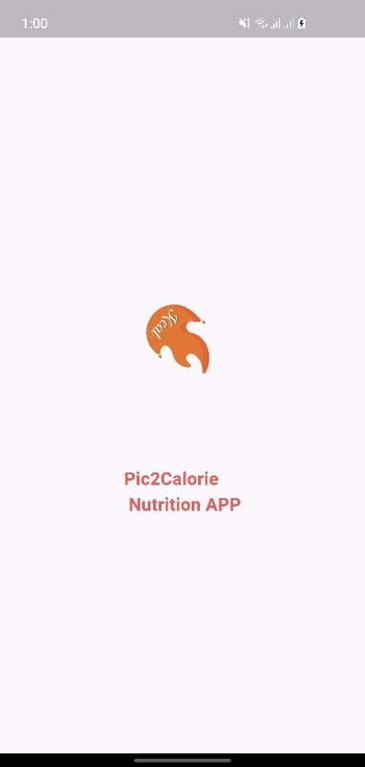
Figure 13: Splash Screen

Login Screen

A light-gray neutral background encloses a huge padlock icon and a warm welcome: "Welcome Back, You've Been Missed!" There are clean, white-lined email and password fields, a "Forgot Password?" link, and a bold black "Log In" button.A message reading "Not a member? Sign Up" is shown below, followed by a divider labeled "Or Continue with" and a tile for Google sign-in. This design aligns security signals with clear calls to action and offers social-login convenience.


Figure 14: Login Page

Home Dashboard

"Hello!! Welcome to Pic2Calorie" welcomes users at top, asserting a friendly UX.The daily step count, e.g., 250 Steps, is also shown on the card along with a progress meter and goal-percent complete.Below is a weekly bar chart showing daily step improvement from Monday–Sunday with the current day
emphasized. The bottom navigation bar (home, dumbbell, food icons) suggests the core modules of the app
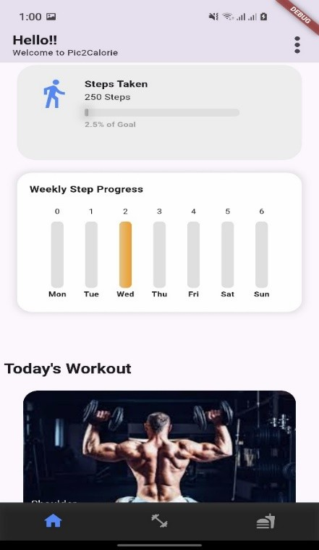

Figure 15: Dashboard

My Profile Overview

In "My Profile," a pastel header and circular avatar placeholder greet the user's space. Four grey input cards display the user's email (two times), first name, and last name, each with a corresponding icon. A top-left back arrow makes back-out easy, and the debug badge remains.
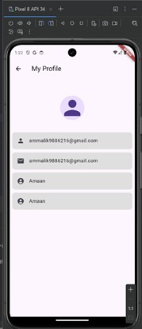

Figure 16:My Profile
    - PROFILE PHOTO PICKER
Tapping the avatar invokes the native photo picker overlay with "Photos" and "Albums" tabs, presenting "This app can only access the photos you choose." The camera-roll section now displays "No photos or videos," educating users about privacy. The omnipresent back arrow is a navigation consistency. This flow nicely balances explicit permission messaging with intuitive OS controls
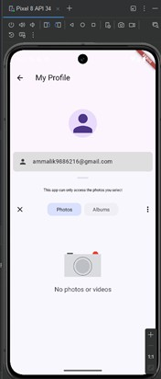

Figure 17: Profile Pic Upload

Workout Selection Screen
Named "Workout – Have Fun Exercising!!," this screen is a vertically scrolling, rounded-cardlist of high- contrast workout images (e.g., Chest, Biceps) with name and duration badge. 2xl corner rounding and soft shadows make the cards feel tactile and contemporary, encouraging users to dive in. A sticky top app bar with back arrow and search icon enables easy navigation, while bottom nav bar icons enable quick switching between home, workout, and nutrition modules. Overall design encourages users to select a muscle group and get going

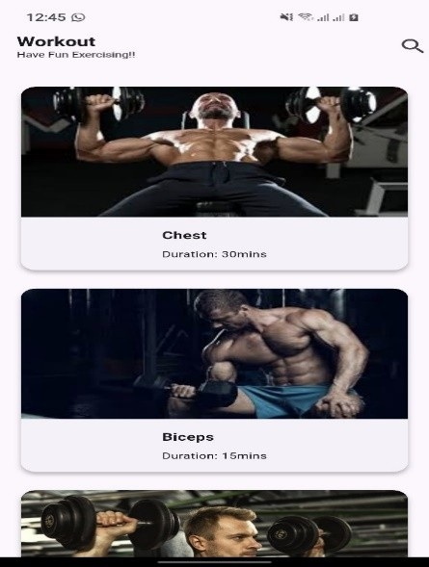
.

Figure 18: Workout Screen Main

Workout Detail Screen
Once a workout is selected, the screen displays a header image of the exercise being done in full-width, engaging the user directly. Below it, the name ("Chest") and "Duration: 30 mins" label are stacked above a short inspirational tagline ("Build your bench and your confidence."). A "Recommended Exercises" list uses dumbbell icons for each exercise—Barbell Bench Press, Incline Dumbbell Press, Push-ups, Cable Flys—utilizing solid spacing and typography. At the bottom, a big countdown timer and three pill-shaped buttons (Start, Pause, Reset) guide users though their session.
.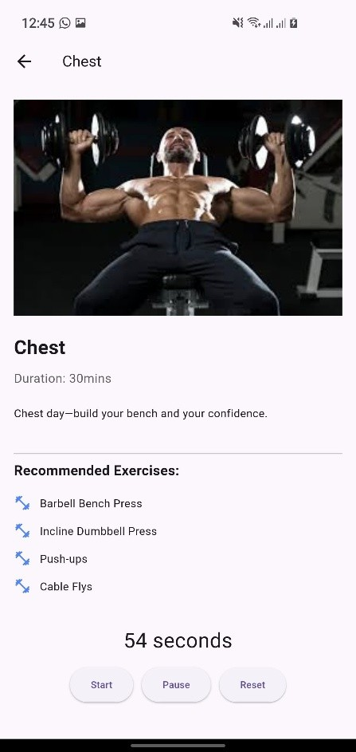

Figure 19:Chest Workout Screen

Food Detection (Search-Only Variant)
Here, in this debug iteration, the same black background displays a centrally located magnifying-glass button, suggesting a search-first process. The top bar and bottom nav icons are retained to provide consistent context even during UI experimentation. This is a mockup of an alternative prototype where users input keywords rather than image uploads. This is centered on iterative UI testing to identify the most intuitive detection entry.
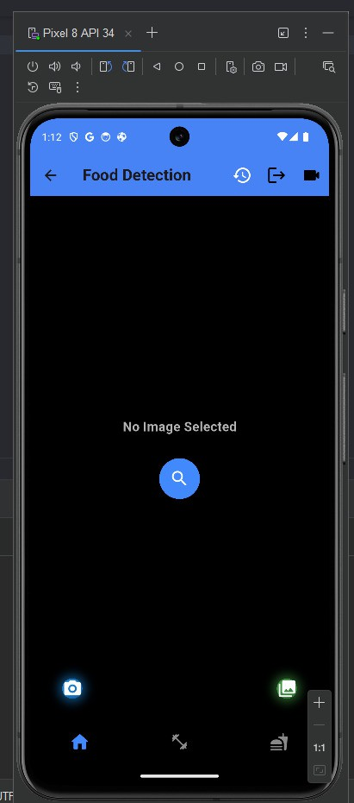

Figure 20: Food Detection Screen

Detection Result

Once a picture is chosen, a dark curved card shows the image of the food, the labeled prediction "3 Samoosa," and confidence "74.81%." Back arrow, history, and share app bar icons are still available for easy navigation. At the bottom, retake/camera/gallery icons are still available for easy retaking or choosing an alternative photo. This prompt feedback screen enables users to view model output without waiting to view full nutrition information.
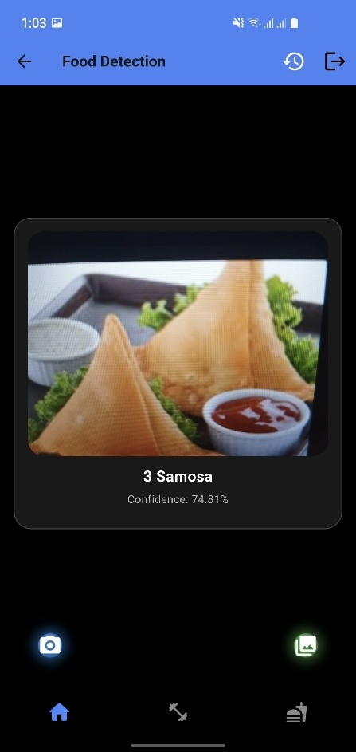

Nutrition Detail Screen
Named "Samosa Nutrition," this view begins with a circular food icon and large heading. Macros: Calories (260.8 kcal), Carbs (24.2 g), Protein (3.5 g), Fat (17.4 g), and Fiber (2.1 g) are displayed on a transparent card with an easy-to-understand icon. Soft shadows and rounded corner cards give it a clean, modern look. A back arrow in the header takes you back to the result screen for simple modifications.
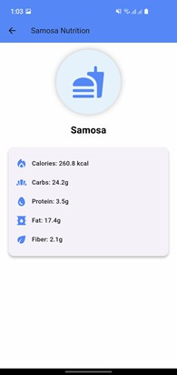

Figure 22:Nutrition Details

Detection History
Under the "Detection History" title, two rounded cards of previous entries—"paratharoll" and "Samosa"—preceded by a food icon and made tappable links appear. A back arrow in the top-left returns one to the detection screen, and a trash-can icon in the top-right indicates bulk-deletion ability. Empty space below adds emphasis to the log with chronological ordering, and a bold blue "View Total Calories" button at the bottom encourages users to view their total intake. This screen neatly organizes previous detections and guides users to summary information.
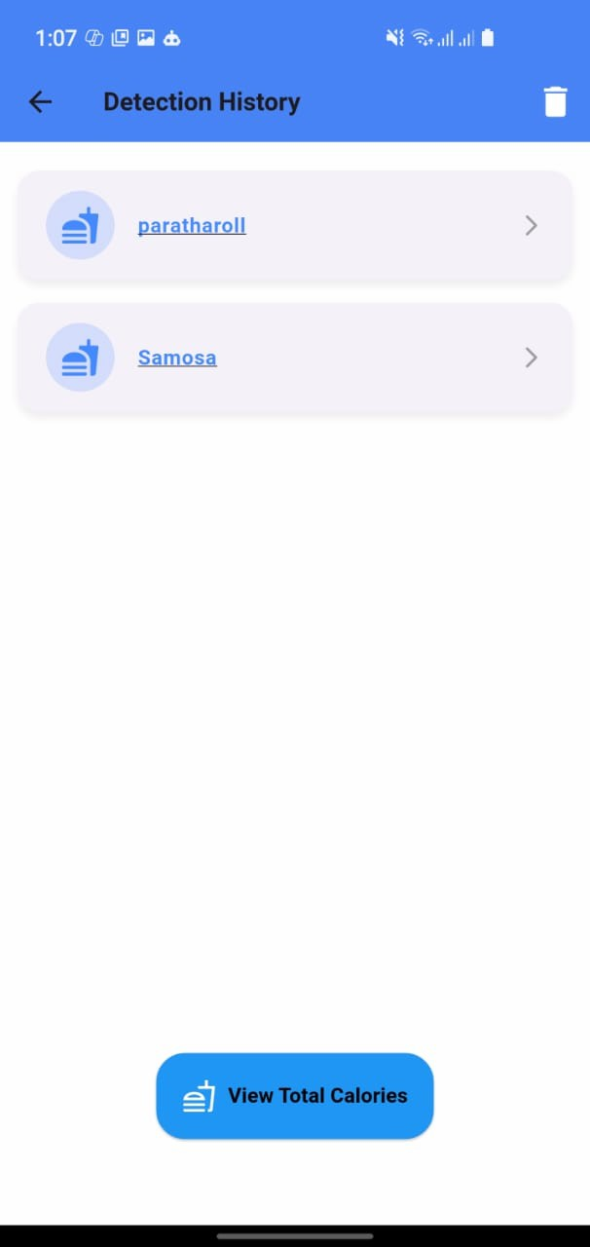

Figure 23:Detection History

Total Calories

Named "Total Calories" with an orange app bar, this page places a transparent card with a flame icon centered on the screen above the bold, prominent "Total Calories Consumed." The prominent red large number "521.60 kcal" represents the user's total intake, grabbing attention as soon as the screen opens. A blue rounded "Go Back" button at the bottom allows users to return to history or home dashboard. This brief summary page shows a clear, visually pleasing snapshot of daily nutritional achievement.
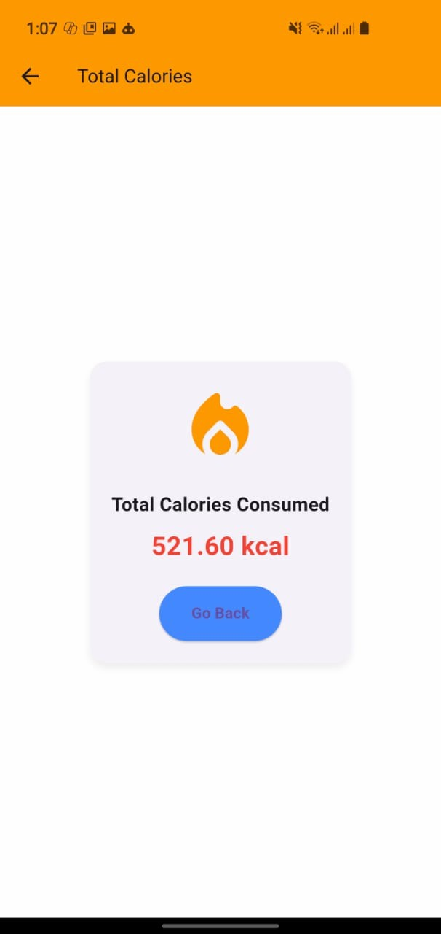

Figure 24:Total Calorie Screen

Nutrition Search (Empty)
On the "Nutrition Search" page, a mint-green header and rounded input field encourage typing, and a gentle "No results yet. Try searching for something!" message fills the void. The search icon in the input field glows in corresponding green. This void-state design invites new users to begin a search.
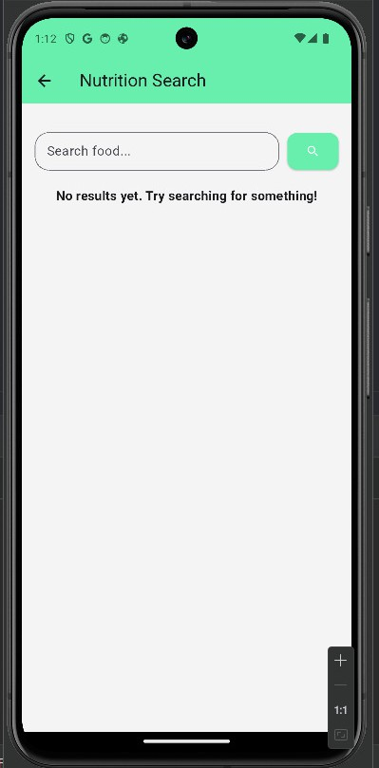

Nutrition Search (Results List)
Once you enter "Salad," a scrollable list of result cards appears—each with a thumbnail (or icon), item name, and right-arrow chevron. The white cards have subtle soft shadows and uniform padding for that tactile experience. The mint header and search bar stay at top for instant refinement. This list proves successful API integration and easy navigation to detail views.
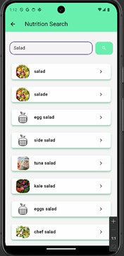

Figure 26:Manual Label Search

Nutrition Detail Popup
A tap on a result opens a modal in the center with a circular icon and a title "SALAD" in uppercase. At the bottom, a simple list displays Calories (19.98 kcal), Protein (1.23 g), Carbs (4.21 g), and Fat (0.2 g). A green "Close" button closes the popup back to results. This overlay with a specific purpose displays nutrition facts without the full page transition.
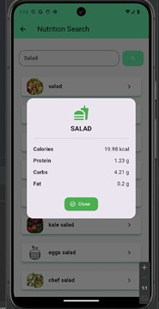

Figure 27: Manual Label Results

Profile Slider

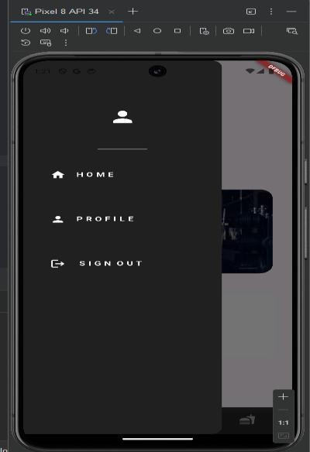
A tap on the drawer opens up the profile slider with the user image displayed along with Home, Sign out, and Profile Tab. Each Tab has a different functionality, where tapping sign- out opens up a drawer that allows users to sign out from both Google and Email as required in just one click.

Backend Infrastructure & Data Management
Pic2Calorie's backend is developed with Firebase, employing Firebase Authentication to securely authenticate user sign-up and login with email/password and social providers. User information is stored in a UserDetails collection in Firestore with documents keyed by UID that contain demographic fields such as name and email. Daily activity is stored within each user document with two subcollections—calories and steps—where each entry is timestamped and keyed by date for efficient querying. This structure, along with Firestore's real-time sync and offline capabilities, provides robust data persistence and rapid access across devices.

Firebase Authentication Dashboard
The Firebase Authentication console displays all Pic2Calorie users by email, sign-in provider, creation time, and last sign-in time, providing administrators with a clear picture of account activity. A global search field provides filtering by email, phone number, or UID, and the "Add user" button provides manual account provisioning. Icons beside each provider (email or Google) indicate how users signed up. This centralized interface provides secure, auditable onboarding and login management.
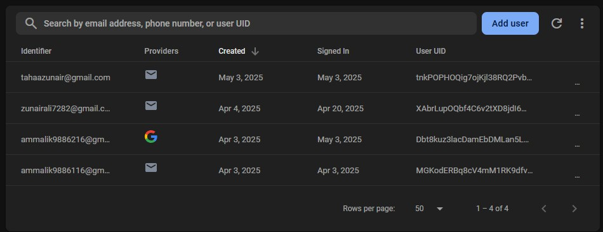

Figure 29:Authentication Table Firebase

Firestore Data Structure Overview
At the top level, two collections—UserDetails and users—store profile metadata and everyday activity logs in separate collections. The UserDetails collection stores one document per UID with static fields, while the users collection stores per-user subcollections with dynamic data (calendars and steps). Sidebar buttons such as "Start collection" and "Add document" point to Firestore's document-oriented flexibility. This structure strikes a balance between schema cleanliness and real-time syncing scalability.
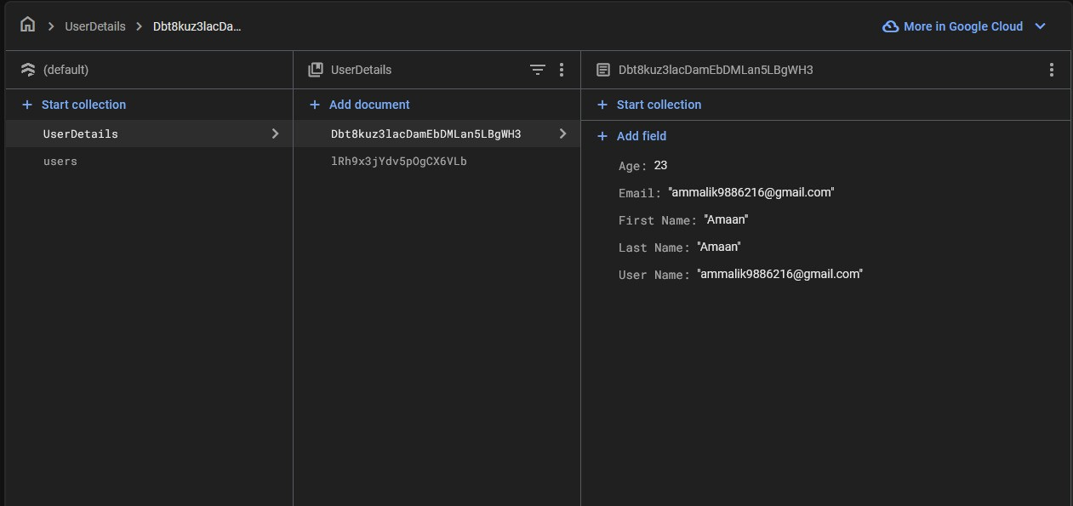

Figure 30: Firestore UserDetails

Firestore – Daily Calorie Record
In users/{UID}/calories/{date}, a document contains that day's consumption as a string of human- readable dates, a Firestore timestamp, and the numerical Total Calories value (say, 1564.8). Document- level indexing by date allows for effective querying by range for dashboard charts or history screens. The model can support both offline updating and real-time aggregation across devices. Field naming conventions that are consistent simplify data parsing in the Flutter client.
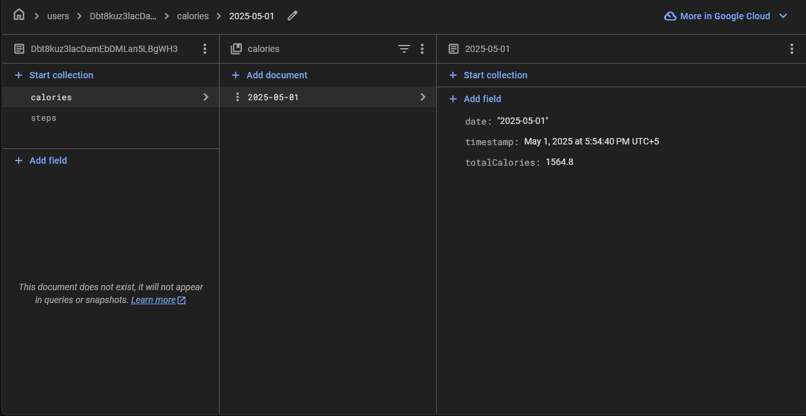

Figure 31:Firestore Calories
Correspondingly, users/{UID}/steps/{date} documents hold step totals by date, such as the steps integer and a creation time. This date-keyed format supports fast lookup of weekly or monthly walking totals to graph. The Firestore console display demonstrates how Hive-backed local logs synchronize cleanly online. The Date-keyed grouping of steps provides scalable storage and easy querying for progress tracking.

Hive Storage/Firestore Terminal
All the Calories are being stored in the Hive Database first, from where they are fetched and saved into Firestore, and on app restart, the calories belonging to a specific {User-ID} are displayed.
The daily registered steps are also saved to Firestore with each {User-ID} and loaded from Firestore for UI. After each new day, the Calories for each user reset to 0, maintaining a good record in the database.
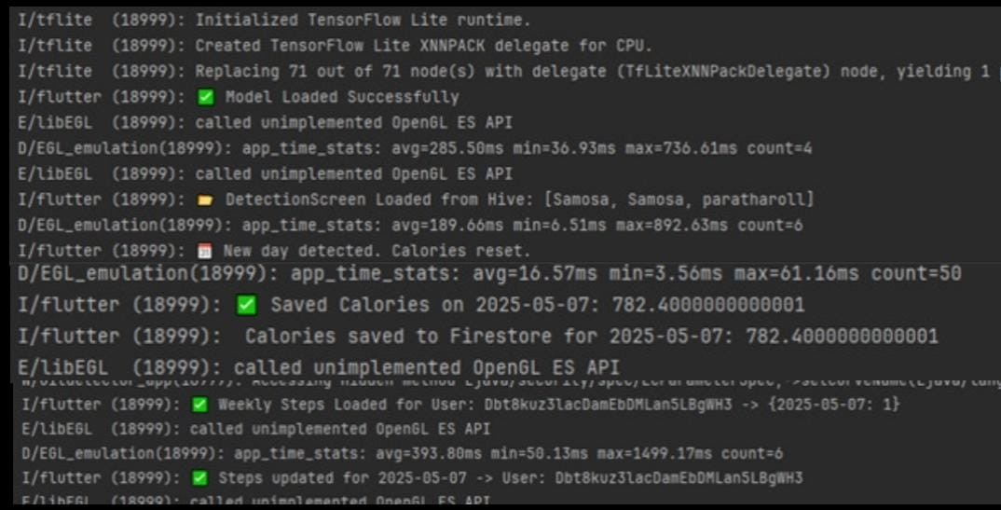

Figure 32:Terminal Results Storage

Chapter 8

CONCLUSION AND FUTURE WORK

Conclusion
The Pic2Calorie app effectively solves the primary issue presented in the introduction: the inefficiency and inappropriateness of manual calorie counting in everyday life. Through the use of machine learning, real-time food identification, step tracking, and exercise tracking, and cloud-synced storage, the app offers a smart, efficient, and easy-to-use solution for health- conscious users. The use of a TFLite model, trained from a fine-tuned ResNet50, enables the app to scan and identify food items automatically with the camera and display nutritional information using Calorie Ninja API. Not only is it quicker, but it also provides a more objective and unbiased measurement of what one is consuming. Where detection is not possible or unreliable, the addition of manual entry through the Nutritionix API provides users with the ability to input food information and gain accurate nutritional breakdowns. The exercise logging and step counter feature further enhances the app's functionality by providing an end-to-end health tracking experience. The physical activity calories are quantified and displayed in the form of a graphical representation, providing the users with actionable insights regarding their health trends. Secure authentication with Firebase and persistent storage with Hive and Firestore guarantee that user data is synchronized, secure, and accessible across sessions and devices. The development was extensively tested with various testing approaches, including unit testing, widget testing, and integration testing, where results indicated the app consistently met functional specifications and ran in a stable state under various contexts.

Evaluation Summary
Several evaluations were conducted to ensure the software meets the project’s goals:
    - Model Accuracy: The TFLite model demonstrated high accuracy (~85%) during inference testing, correctly classifying food items in the majority of test cases.
    - Performance: The app maintained a fast response time for model inference, API requests, and Firebase operations.
    - User Acceptance: Preliminary user feedback indicated high satisfaction with the ease of use, automation features, and UI responsiveness.
    - Testing Results: All major functionalities, such as manual food logging, authentication, and step tracking, passed their respective test cases during controlled walkthroughs and simulated scenarios.
These findings confirm that the solution is technically sound, practically applicable, and successful in addressing the core problem.

Recommendations
While the Current Application works well, the following suggestions could improve its functionality:
    - Model Optimization: To Further Quantizing and Compressing the Model could help improve interference speed and reduce the overall memory usage.
    - Nutritional Goal Setting: Introducing the weekly or daily nutritional goals could really help users monitor their dietary habits more pro-actively.
    - User Feedback System: Allowing users to provide feedback on food detection accuracy could be used to retrain and refine the model. Allowing the users to provide feedbacks on food detection accuracy could really help to further refine the model or re-train it.
    - Integration with Wearables Devices: To sync data from smartwatches and fitness bands could improve the accuracy of step and workout data.

Future Work
Looking ahead, several enhancements are planned to extend the application's functionality:
    - AI-Based Sized Portion: Future versions will incorporate Computer vision algorithms to estimate portion sizes from images, further refining the calorie predictions.
    - Support For Multilanguage: Making the application accessible in multiple languages to reach a wider audience.
    - Meal Planning and Diet Suggestions: The App may make recommendations for healthier options or meal plans based on the user’s dietary performance.
    - Gamification: Using health challenges or reward systems to encourage user participation.
    - Dashboard for Advanced Analytics: Weekly Comparisons, tailored advices, and more thorough insights into dietary habits are being added.
By pursuing these directions, Pic2Calorie aims to evolve into a Comprehensive health assistant and nutritional app that supports a wider range of wellness goals.

